**READY, STEADY…COOK!**

**RED LENTILS & VEGGIES KEBAB BY VEDANTIKA**

Hello!

Here is my recipe for the school menu.

**Inspiration for Dish:** Vegetables are healthy but sometimes vegetarian dishes are not much tasty. I add so many vegetables in my recipe to make a healthy and nutritious dish. It’s super easy to make and super delicious to taste.

**Name of Dish:** Red Lentils & Veggies Kebab

**Ingredients List:**

1. 1 cup Red Lentils (soaked for 20-25 minutes)
2. 1 inch of ginger (roughly chopped)
3. 4 cloves of garlic (roughly chopped)
4. 1 cup flat leaf parsley or cilantro
5. ½ cup of bread crumbs
6. Salt to taste
7. ½ tea-spoon garam masala powder (optional)
8. 1 tea-spoon paprika powder
9. 1 tea-spoon cumin powder
10. 1 tea-spoon black pepper powder
11. Juice of 1 lime or lemon
12. ¼ tea-spoon of baking soda
13. Vegetables (any vegetables of your choice): Potato, Carrot, Beetroot, Cabbage, Peas, Onion (grated as much as you like, I took 1 cup of each)
14. 1 tea-spoon of cooking oil

**Instructions:**

**Step 1:**

1. First, wash 1 cup of red lentils.
2. Now, soak the red lentils in water for 20-25 minutes.
3. After 25 minutes, drain the water carefully.

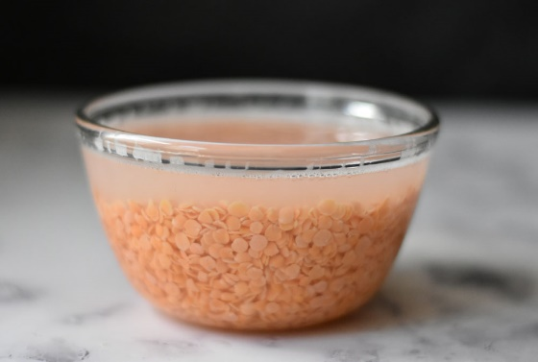

**Step 2:**

1. Then, make the preparation for veggies.
2. Take 1 medium onion (finely chopped), 1 medium potato (grated), 1 medium carrot (grated), 1 cup of finely chopped cabbage, 1 medium beetroot (grated) and some green peas.
3. Next, add 1 tea-spoon of cooking oil in a heated pan.
4. Fry all the vegetables.
5. Add ½ tea-spoon of salt and mix it all well.
6. Fry it for 4-5 minutes in medium-high heat to cook out the extra moisture of the vegetables so that the kebab mixture does not get soggy.
7. When the veggies are cooked well, keep it aside for cooling down.

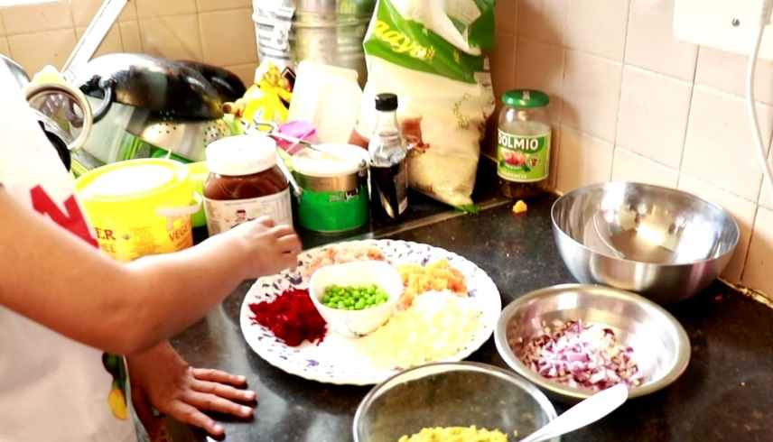

**Step 3:**

1. Add the soaked red lentils in a food processor to grind.
2. Please note, the lentils should be thoroughly dried out by dabbing it with a paper towel.
3. Then, add the 1 inch of ginger, 4 cloves of garlic and 1 cup of parsley or cilantro in the lentils.
4. Next, add ½ cup of bread crumbs into the food processor.
5. Add 1 tea-spoon of salt.
6. Now, in-goes 1 tea-spoon of garam masala (optional), 1 tea-spoon of paprika powder, 1 tea-spoon of cumin powder, 1 tea-spoon of black pepper powder and juice of 1 whole lime/lemon.
7. Then, process the mixture.
8. Blend it till it has a smooth texture but not like pastry mixture.
9. Keep it aside.

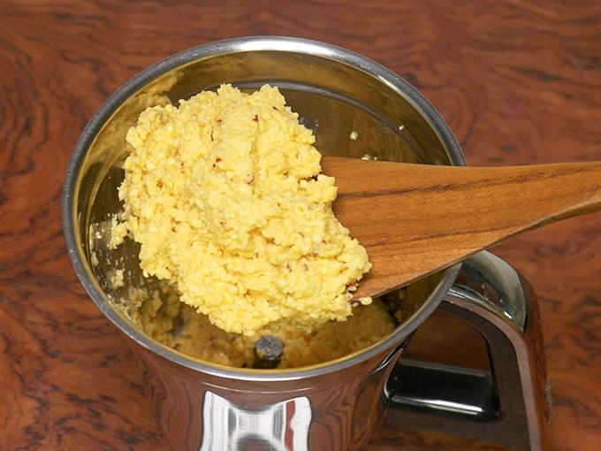

**Step 4:**

1. To a mixing bowl, add the red lentils mixture and the cooked veggies.
2. Also, add ¼ tea-spoon of baking soda.
3. Mix it all very well.
4. Put some oil on your palm so the mixture does not stick during making the kebab.
5. Now, give the kebab any shape as you like. (I made round, oval and heart shaped)

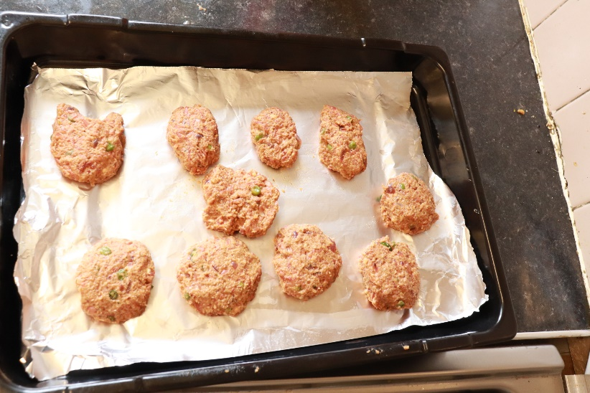

**Step 5:**

1. Pre-heat the oven at gas-mark 6 for five minutes.
2. Put the kebab in a baking tray and insert it into the oven.
3. Alternatively, kebab can be shallow/deep fried in the vegetable oil too.
4. After, 10 minutes, turn the kebabs over for even cooking.
5. Finally, after 10 more minutes, switch-off the oven.

**Step 6:**

1. Red Lentils & Veggies kebabs are now all done.
2. It can be served as appetizer with salad or can be put in the sandwich or wrap for a meal.
3. Garnish it with some grated cheese. (I eat it with green salads and tomato ketchup)

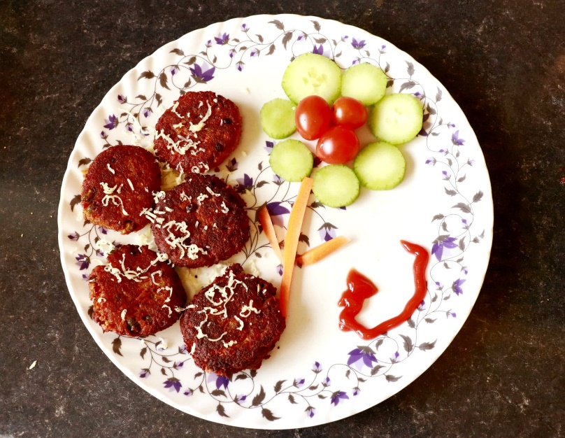

P.S. : Instructions may be looked lengthy but the recipe is easy and I highlight the imperative verbs in my instructions.