**LEARNING KITCHEN COURGETTE AND APPLE MUFFINS - by Ella**

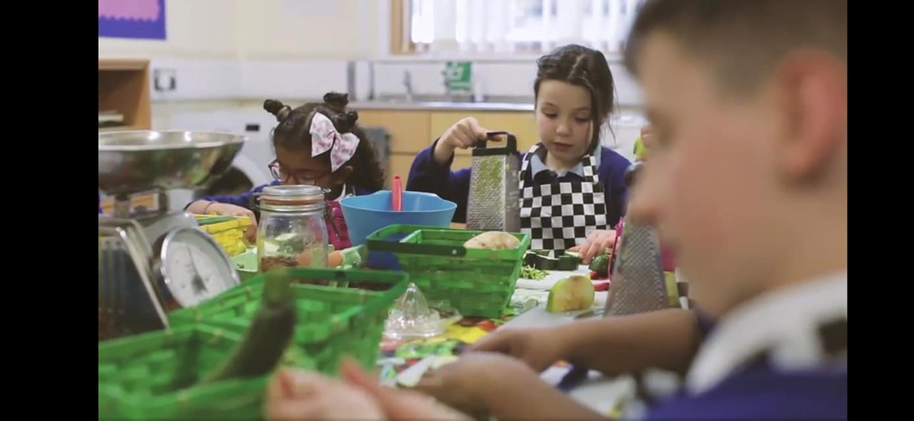

Courgette and Apple Muffins that I baked for the filming of ‘the Learning Kitchen’ video we made for fundraising.

Recipe is here, but I left off the icing to make them healthier, and they were delicious!

[Courgette muffins recipe - BBC Good Food](https://www.bbcgoodfood.com/recipes/courgette-muffins)

