Rubens Recipe – Year 3

Rubens Vegetastic Bean Chilli

Ingredients  250g red lentils  1 tbsp olive oil  1 medium onion  2 cloves garlic  2 tsp ground cumin  Pinch mixed Italian herbs  Pinch salt  Pinch sugar  Pinch chilli powder  1 tbsp tomato puree  400g tinned chopped tomato  500g water  1 vegetable stock cube.  1 pepper  6 mushrooms  400g canned kidney beans, drained | 

Method

1. Rinse lentils  2. Chop all veg  3. Heat oil in pan  4. Add cumin seed and stir for 1 minute, then add onions and garlic and keep stirring. | 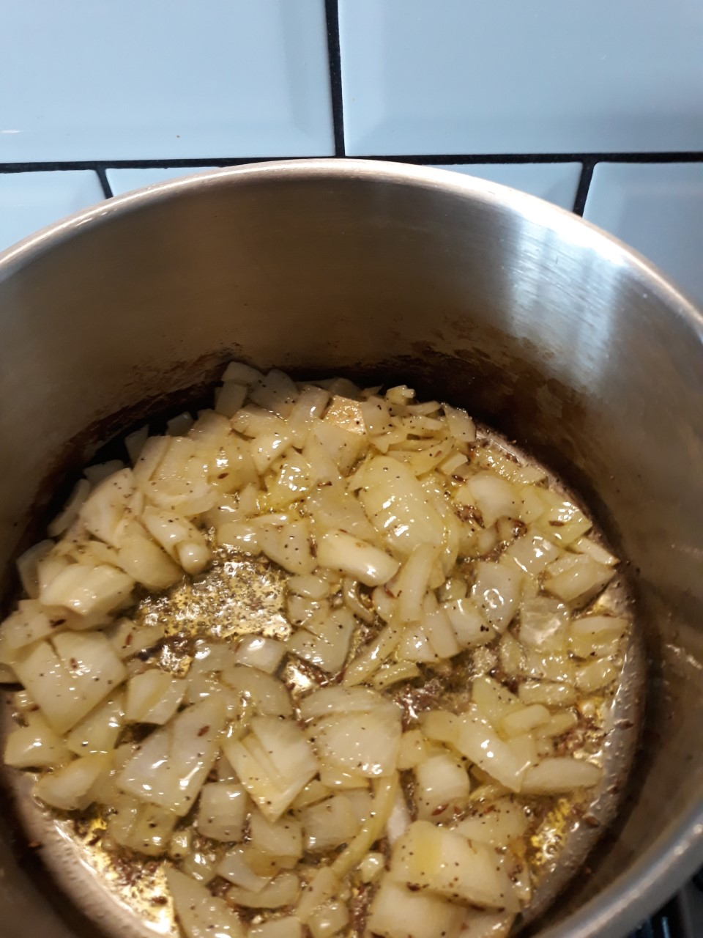
Add tomato puree, salt, sugar, herbs, chilli powder and ground cumin and stir for 2 minutes.  6. Add lentils, chopped tomato, water, stock cube, peppers and mushroom and stir.  7. Cook on medium heat for 15 minutes with lid.  8. Add kidney beans, stir and simmer for 5 minutes.  9. Serve with rice, or in tortilla wraps with grated cheese with a side salad. | 