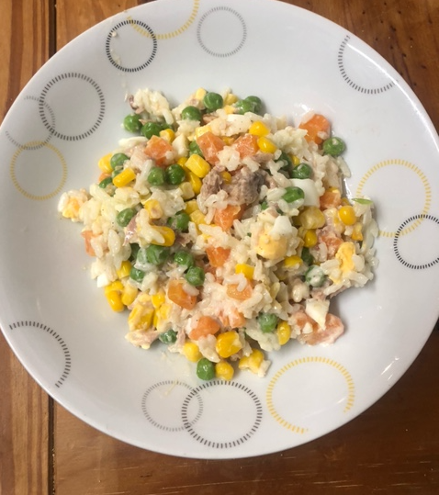

The Mediterranean Dish

This simple but healthy vegetarian dish is very simple and so easy to make. It can be served hot or cold delicious either way. You can add or replace any vegetable.

**Ingredients:**

. 1 cup rice

. 1 cup diced carrots

. 2 boiled eggs diced

. 1 cup sweet corn

. 1 cup frozen peas

. 1 cup tuna optional

. 2 spoons of mayonnaise

**Preparation:**

Boil water in a saucepan, add the rice ,carrots and peas .when cooked, strain and a bowl . Add sweet corn, diced eggs and mayonnaise.. Enjoy!

By Chef Youcef from Emerald