Cauliflower Florets

The inspiration for my dish:
The inspiration for my dish is my grandparents’ home country- Poland. Cauliflower is a very popular vegetable over there. It is very nutritious (Vitamin C, Vitamin K, calcium and iron, potassium and magnesium), good source of fibre, tasty and suuuper healthy.

The name of my dish:
Colliflower cutlets

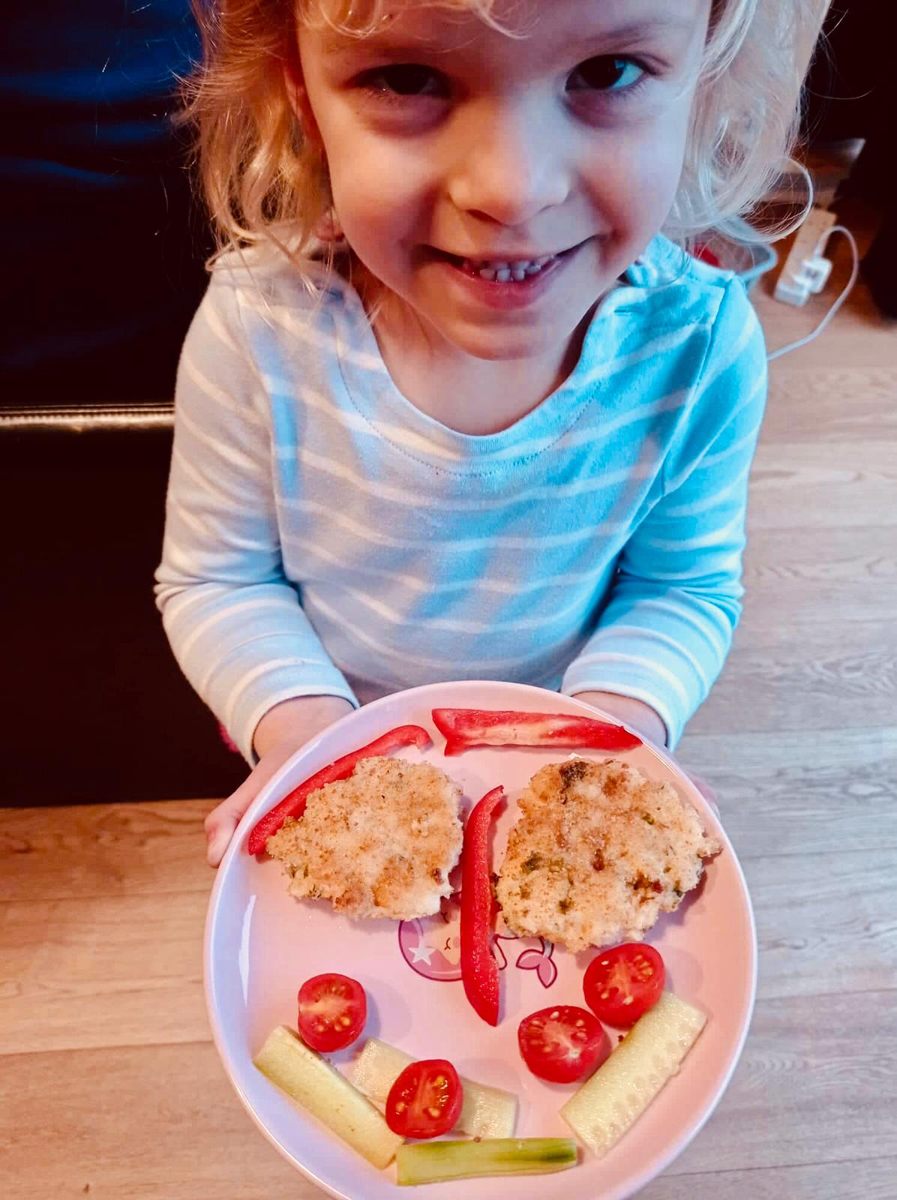
Ingredients list (for 12- 14 cutlets)

- 1 small cauliflower
- 100 g of white rice
- 1/2 bunch of dill
- 1 egg
- 2 tablespoons of flour
- 2 tablespoons of breadcrumbs
- herbal pepper
- salt pepper
Additionally:
- frying oil
- breadcrumbs to coat the cutlets

Instruction:
Divide the cauliflower into florets, wash and cook it in steam or in lightly salted water.
Then put it into a bowl and mash it with a fork. Boil the rice according to the recipe on the package and when it is cool, add it to the mashed cauliflower. Then beat the egg, add chopped dill, flour and breadcrumbs. Knead to a homogeneous mass. Season to taste. Preheat the frying pan, form the patties, roll them in breadcrumbs and fry on both sides until golden brown. Serve cold or warm, with salad or a sauce, such as tomato.

