ROCKMOUNT PRIMARY SCHOOL
Calculation Policy
Date: January 2023
Review Date: January 2024

Introduction
This document provides examples of progression through the various calculation methods to support problem solving using the four operations (addition, subtraction, multiplication and division). It is based on the calculation methods from Big Maths (CLIC) which Rockmount Primary School has adopted in the teaching of all areas of maths.

Aim
The main aim of this policy is to ensure a consistent approach throughout the school which will improve the understanding and attainment of pupils in line with the development of mental and written calculations in addition, subtraction, multiplication and division. Written methods should always follow and support understanding. It is important to note that they are not age-related but progressive. It is important that pupils’ calculation methods develop through each stage and do not move on to the next stage until they are ready.

How the policy is organised
The policy is organised into four separate sections, one for each of the four operations. Each operation progresses from ‘high level understanding methods’ (Big Maths) to the short column methods. The column methods run alongside the ‘high level understanding’ methods and both should be taught as part of the pupils’ mathematical journey through Rockmount. More details about each individual learning step, high understanding method and column methods can be found online at BigMaths.com or in the Big Maths books kept in the PPA room.

Addition: Progress Drive

The Addition Progress Drive can be split into 4 broad phases of development
Phase 1: Steps 1 – 20 (2d + 1d)
The first phase covers all of the high-understanding foundation mini-steps that allow a child to smoothly progress from understanding what addition is to the key milestone of being able to add any 1d number to any 2d number. It is vital that all children are carefully tracked so that they are solving this by partitioning the 2d number and then adding the 1d numbers together before adding on the tens number. Although all children will start by counting on, children that have not mastered the partitioning approach will find further progress after this point less easy. This first phase then is about moving from ‘counting on’ to partitioning.

Phase 2: Steps 21 – 25 (2d + 2d)
The second phase is the move towards being able to add two 2d numbers together, initially on paper but then also mentally and then by using the column methods. Although it is not a huge leap past Step 20 mentioned below, it is a significant milestone that is characterised by a need to show much greater mental capacity and so the move along the FAB continuum is the main focus of this phase. It is also at Steps 24 and 25 that we have the introduction of the Column Methods as children now start to develop along two paths; the high understanding FAB maths presented here, but also the more efficient column methods found in the ‘The Big Maths Column Methods’ book.

Phase 3: Steps 26 – 29 (3d + 3d using FAB maths)
The third phase is characterised by the ability to turn one addition sentence that can’t be solved immediately into 3 composite sentences that can all be solved using Pim’s Addition. Our focus now is on developing ‘FAB Maths!’ (i.e. mental maths) as we give the learner a high understanding written method but then take the writing away gradually as they progress with their ability to hold numbers in their head.

Phase 4: Steps 30 – 41 (the 3-sentence approach using FAB maths)
The fourth phase is concerned with developing further and using the 3-sentence approach to now solve addition questions with money and decimals.

Addition Steps: High Level Understanding Methods

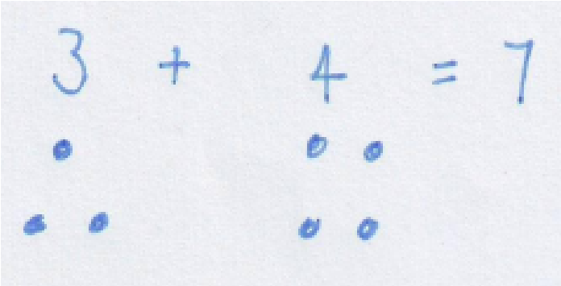
Step1: Using physical objects to count and add on.

Steps 2-5: Finding totals using objects.

Steps 6-8: Reading and understanding number sentences and solving them using objects such as counters and cubes.
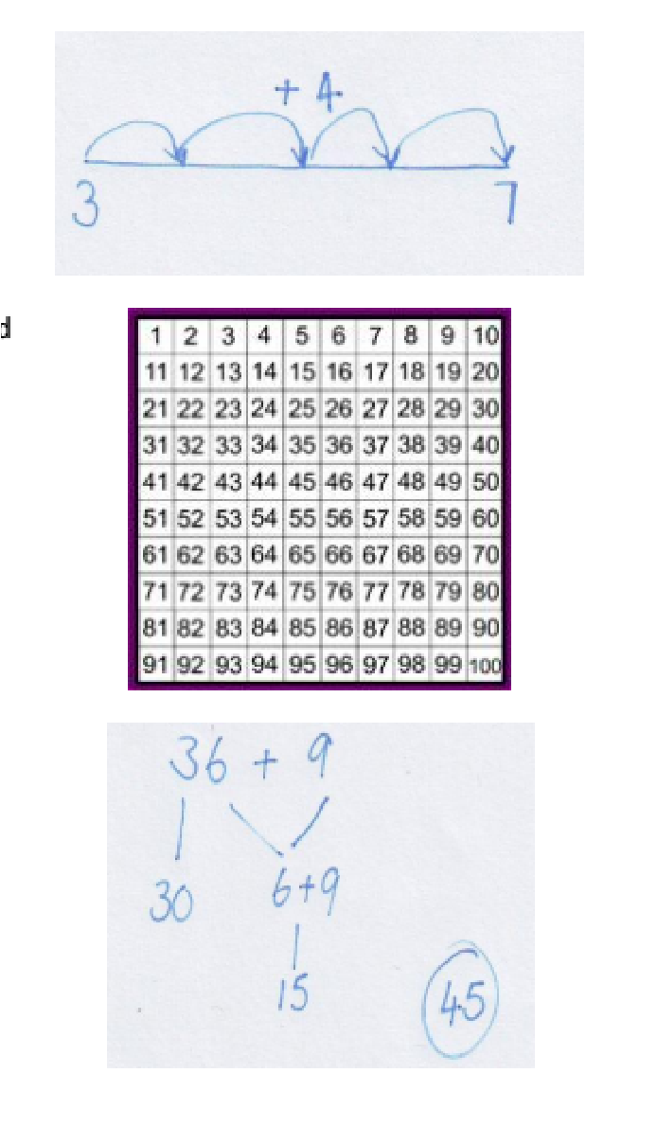

Steps 9-12: Use of number lines to 20 and use of an empty number line to record counting on. (Showing working out to support answer / reasoning)

Steps 13-19: Use of 100 squares to add on in 1’s and 10’s and a combination of these.

Step 20: The use of ‘partitioning’ to add 2d + 1d

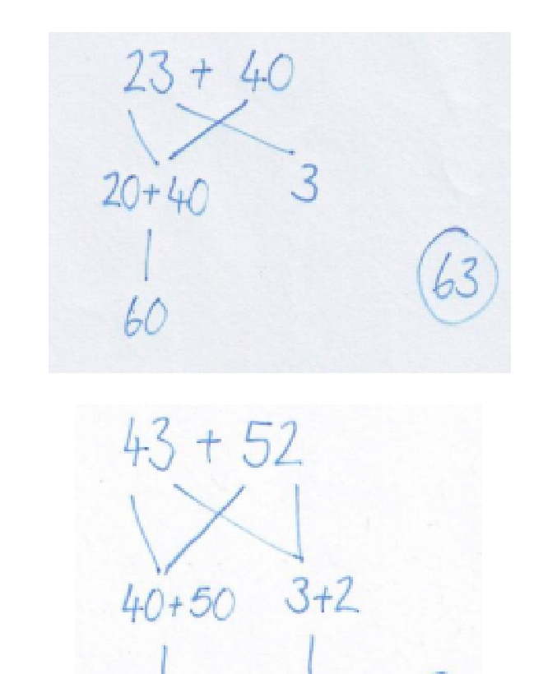

Steps 21-22: The use of partitioning to add 2d + 2d. starting with multiples of 10

Steps 23-25: The use of partitioning to add any 2d + 2d

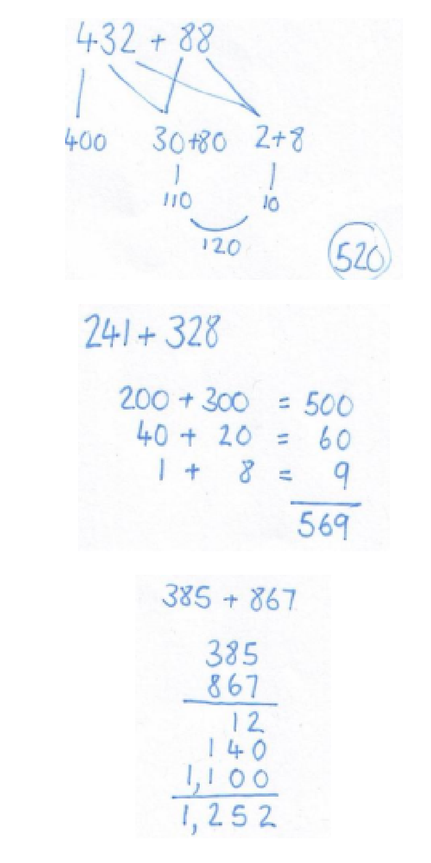
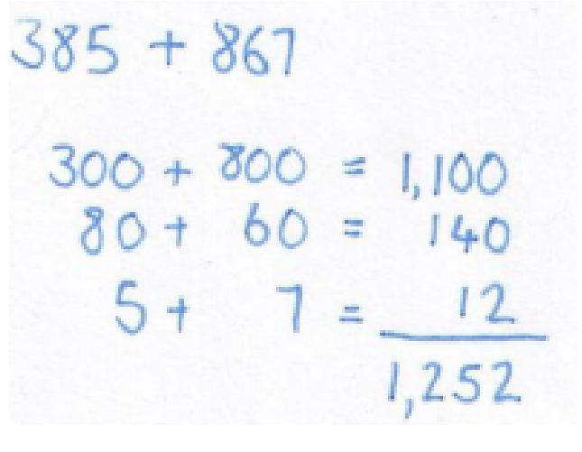
Steps 25-27: The use of partitioning to add 3d + 2d

Step 28: The use of more formal methods to add 3d + 3d

Step 29: The use of more formal methods to add 3d + 3d

Step 29: The use of more formal layouts to add 3d + 3d, including where bridging is required.

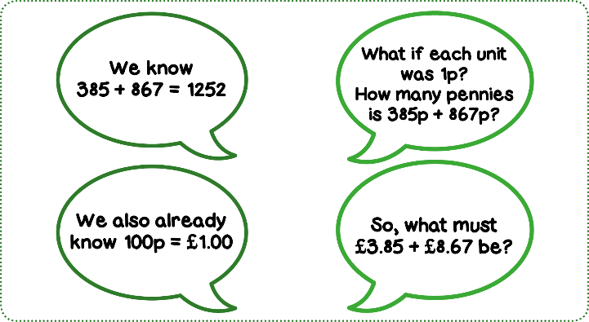

Steps 30-33: Adding decimals to 2dp in the form of money
e.g. (£2.34 + £3.25)

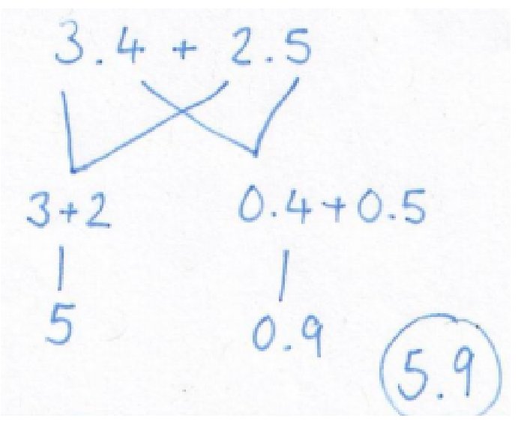
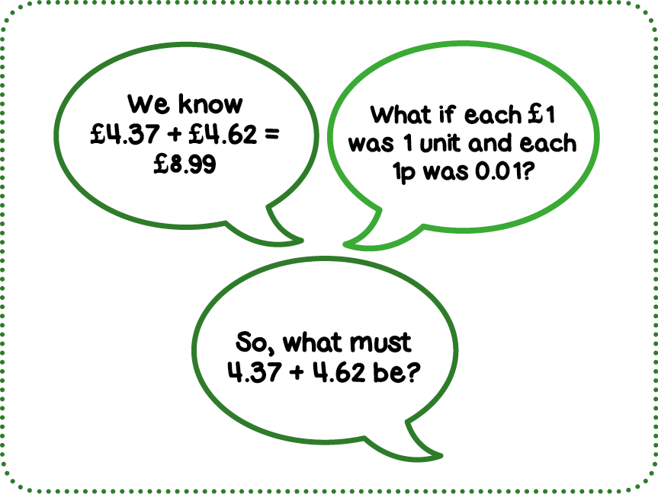
Steps 34-37: Addition of decimals: U. 10th + U using partitioning, Moving onto U. 10th 100th + U. 10th 100th


Step 38: Extending to include 4d and various combinations of TH, H, T, U



Step 39: Addition of several numbers.

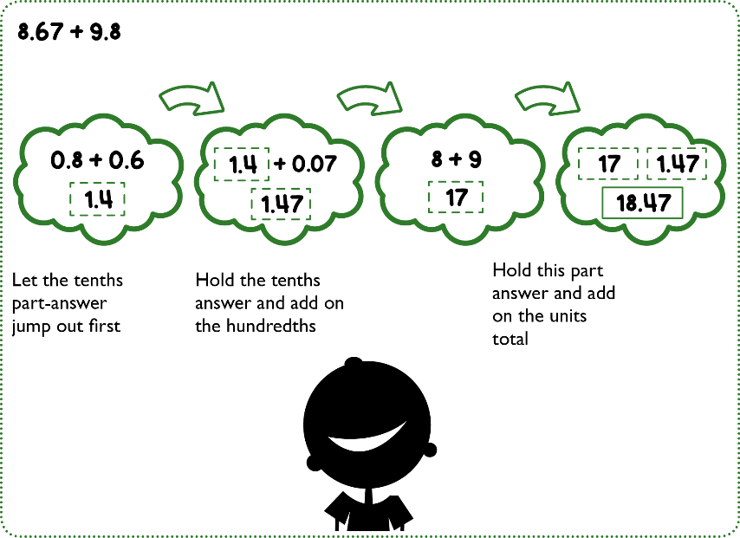
Step 40-41: Adding numbers with varied digits before and after the decimal place including those that require bridging. E.g. 8.67 + 9.8

Addition: Column Methods

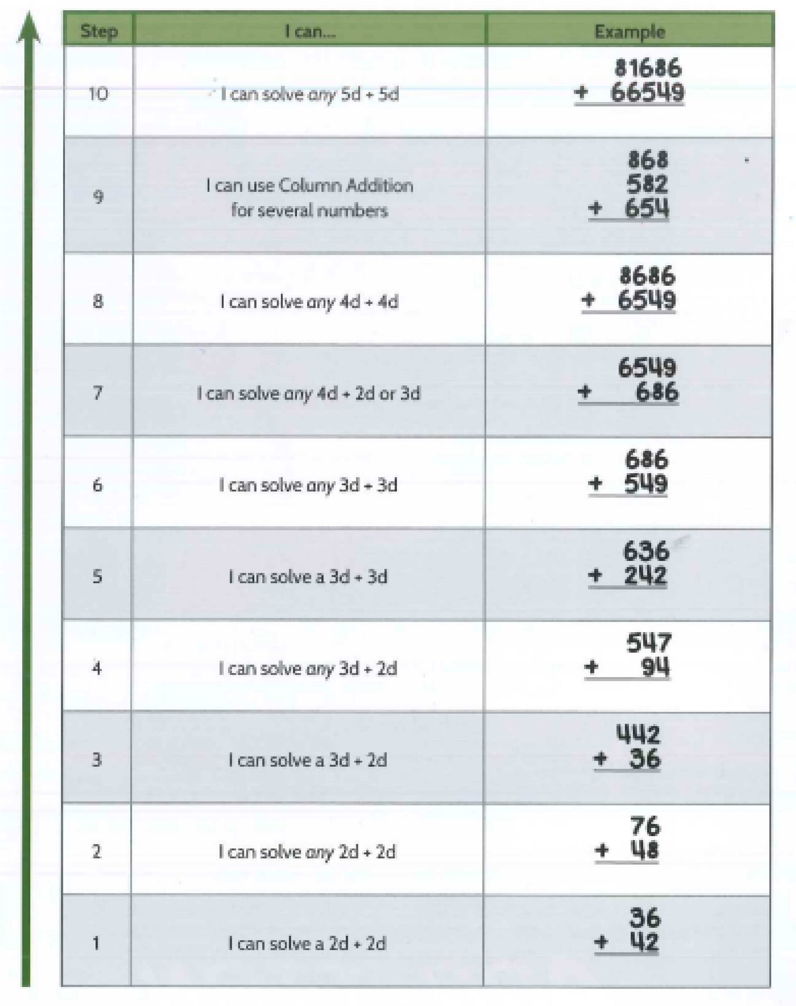

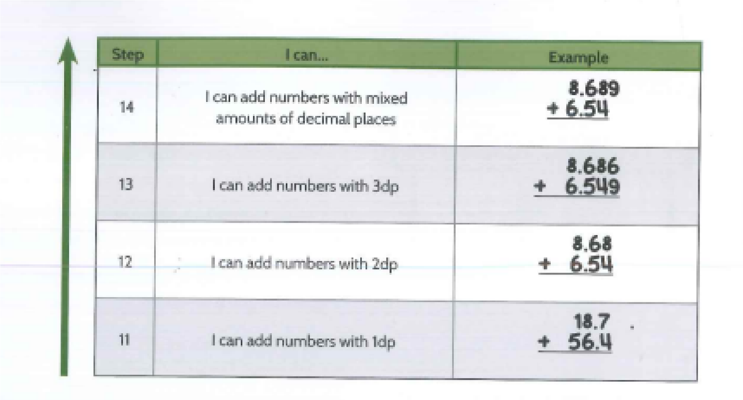

Subtraction Progress Drive

Overview of Steps
It is easily recognisable that to solve 452 - 8 one would need to think about reducing the number 452 by 8, however to solve 103 - 98 one would be better off thinking about how many more are needed to increase 98 to 103, in other words, ‘What is the gap between these numbers?’
If we accept, therefore, that some subtraction questions will be solved by a mindset that essentially says, ‘Let’s count backwards and see where we land’, and that other subtraction questions will be solved by a mindset that basically says, ‘Let’s find the gap between these numbers’, then it is important to organise within a school when and how children learn counting backwards subtraction and when the children learn a going forwards, ‘find the gap’, method of subtraction. To make such a distinction leads to a well-defined, smooth and ultimately successful learning journey for all children.
In Big Maths the Subtraction Progress Drive is organised so that subtraction up to step 19 teaches the children to take away in the counting backwards mode. Within this mode the counting backwards is ‘speeded up’ by skills and knowledge so that it becomes a calculation with shortcuts for the actual counting.
As soon as the child has reached step 19 of subtraction then the mindset changes to one of ‘find the gap’. Some general points about this mindset are made at the start of step 20.Having agreed a single cut off point for the end of teaching and learning for counting backwards and the start of teaching and learning for ‘find the gap’, means that all teachers and children can be left with the highest levels of clarity possible.
Once children learn to go forwards to find the gap, then they should still be given revisit sessions where they need to solve subtraction questions by going backwards. This way all children end up able to do either, depending on the numbers involved, as with the 2 example questions given above. However, all children will have ended up with this adaptable thinking through the highly structured approach set out here.
From Step 20 to Step 27 the learner develops the skills and understanding to solve any 2d - 2d question. It is after this understanding has been put in place that we can start to show children the Column Method for subtraction.
However, there is not a direct link between the high-understanding method and the column method for subtraction as there was for addition. This holds true as we progress up the column method Progress Drive for subtraction. One could explain to children what is ‘really happening’ during column subtraction (including with ‘borrowing’ later on), but it is a laborious discussion and, besides, the whole premise of column methods is that we sacrifice understanding for efficiency.
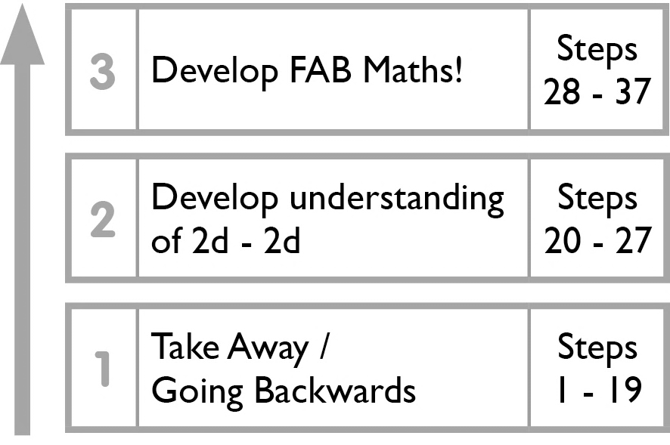
All the more reason therefore that ‘Subtraction Step 27’ has been secured prior to the mechanics of Column Method subtraction being taught from Step 28 onwards. Our focus then turns to developing ‘brain only’ subtraction by using the 2 jump, high-understanding, ‘find the gap’, approach using FAB maths.

Subtraction Steps: High Level Understanding Methods
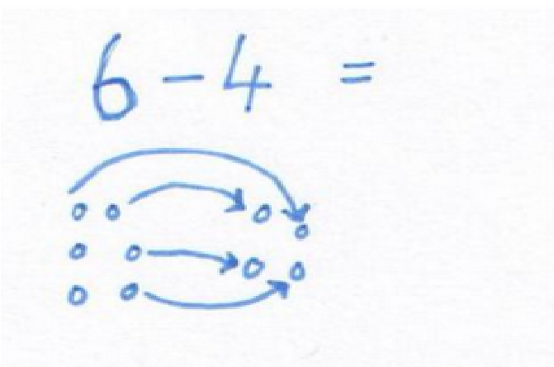

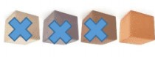
Steps 1-6: Taking some objects away from a group progressing to counting how many are left (All with the use of physical objects)

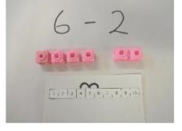

Steps 7-8: Arranging then solving a number sentence by physically setting out the objects

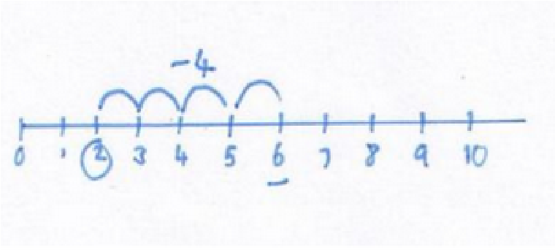

Step 9: counting back on a number line to solve a number sentence.

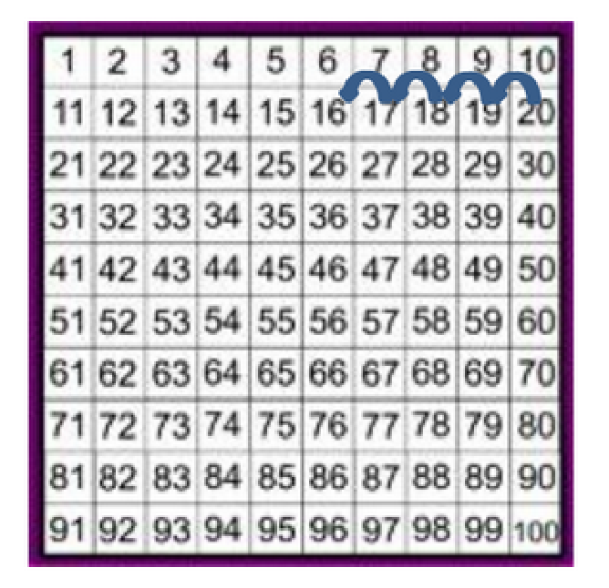

Steps 10 – 11: Using a number line or 100 square to subtract a one digit number from 20 e.g. 20 – 4 = 16
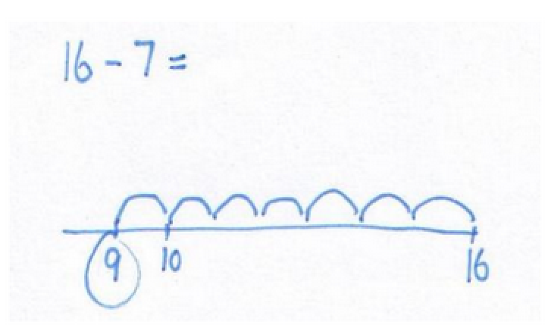

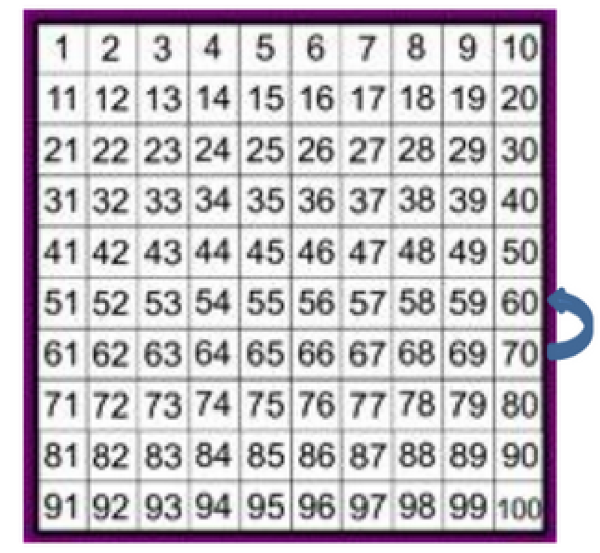
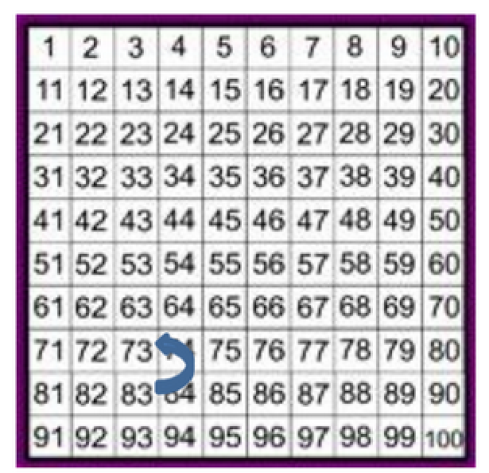

Steps 12-13: Use a 100 square to find a multiple of 10 and subtract 10 e.g. 70 – 10 = 60

Step 14: Use of a 100 square to find any two-digit number and subtract 10 e.g. 83 – 10 = 73

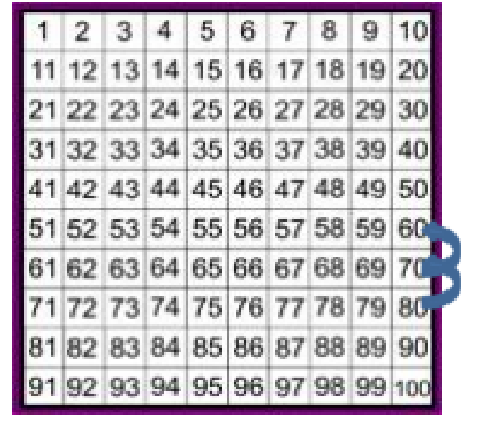
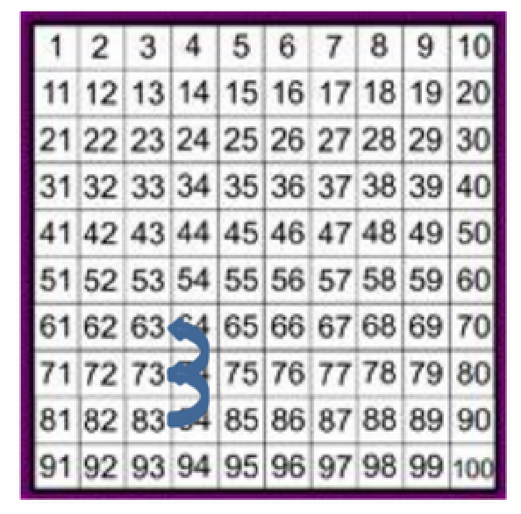

Step 15: Use of a 100 square to find a multiple of 10 and subtract a multiple of 10.
e.g. 80 – 20 = 60

Step 16: Use of a 100 square to find any two-digit number and subtract a multiple of 10. e.g. 83 – 20 = 63

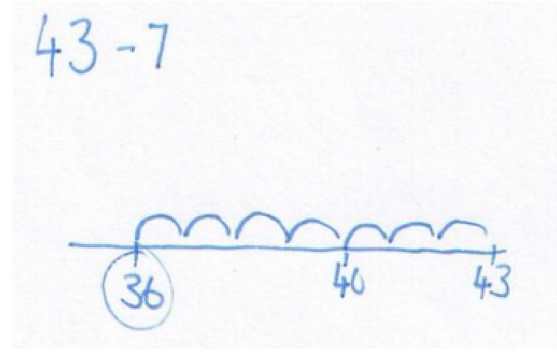
Step 17: Use an empty number line to subtract 2d -1d not bridging tens.

Steps 18-19: Use an empty number line to subtract 2d – 1d, including bridging.

With the focus moving to counting on, each progression below follows the pattern:
- Record numbers at either end of the empty number line (counting on left to right)
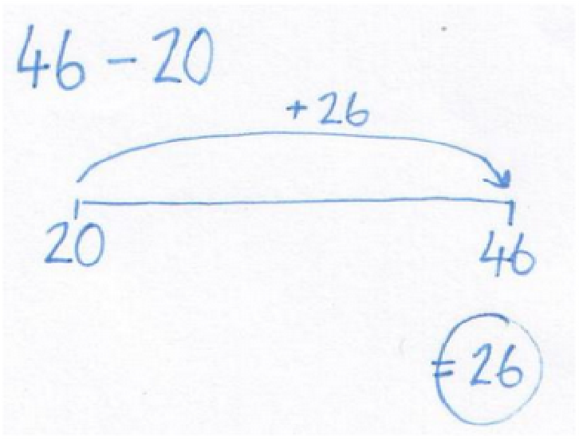
- Making two jumps (multiple of 10 where counting onto < 100, multiple of 100 where counting onto < 1,000)

Steps 20-22: Finding the difference to the next multiple of 10.

Steps 23-24: Jumping from a multiple of 10.

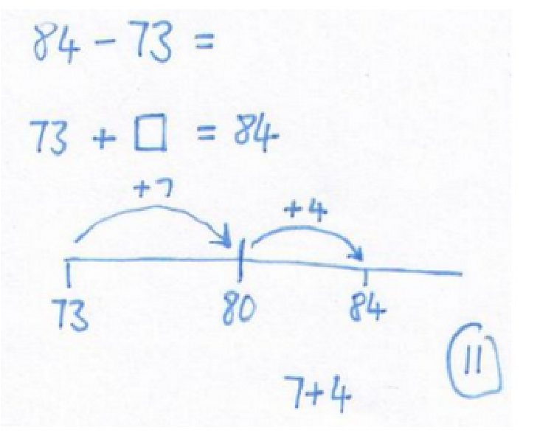

Step 25-27: Two jumps to solve 2d-2d e.g. 84-73

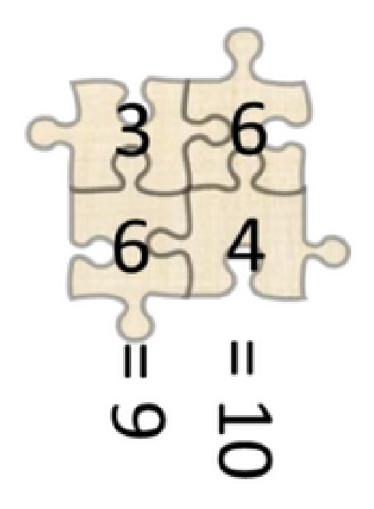

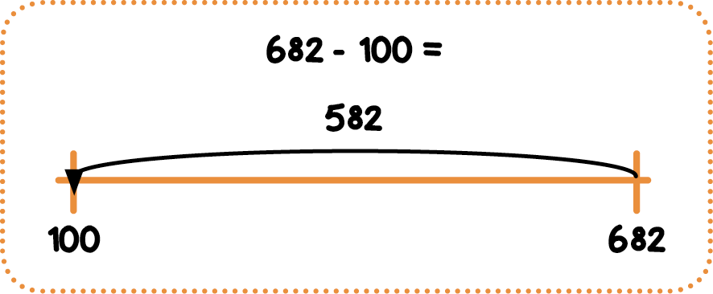
Steps 28-30: Using Jigsaw numbers to take any 2d number away from 100 and using jigsaw numbers to 100 to support subtracting with 3d numbers

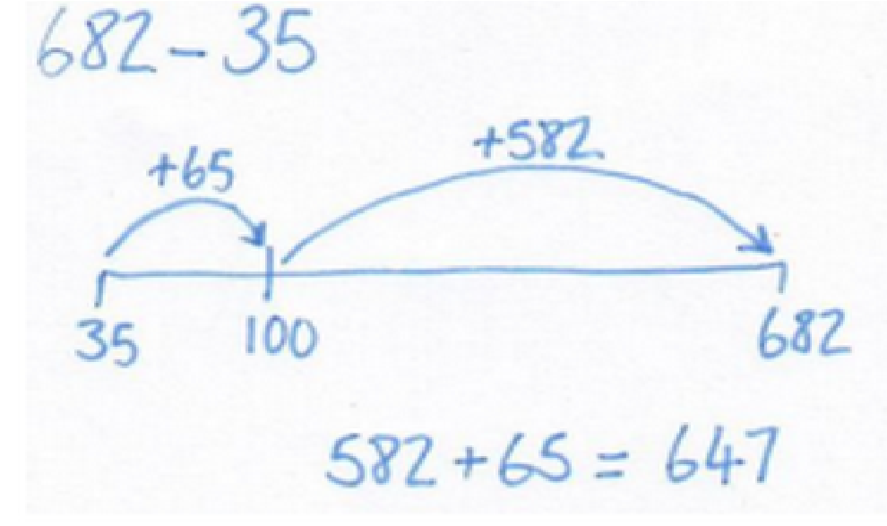
Step 30: Solving any 3d-2d

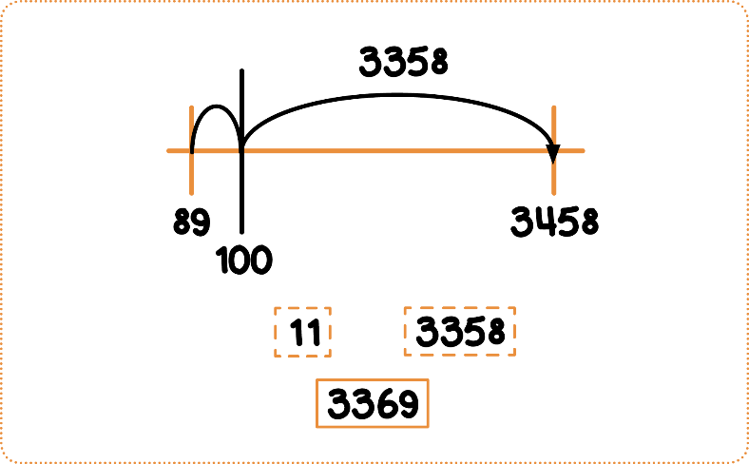

Step 31: Solving any 4d – 2d

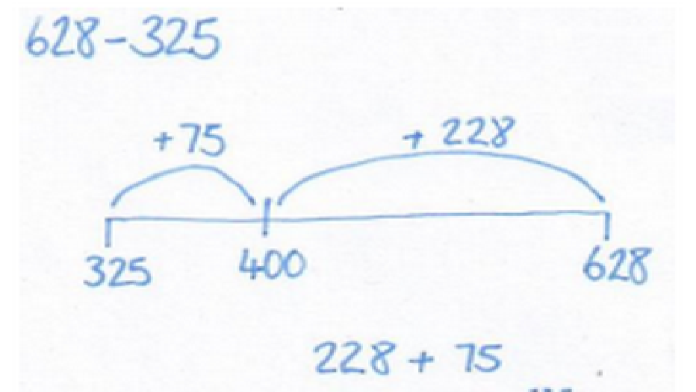

Step 32: Solving any 3d – 3d

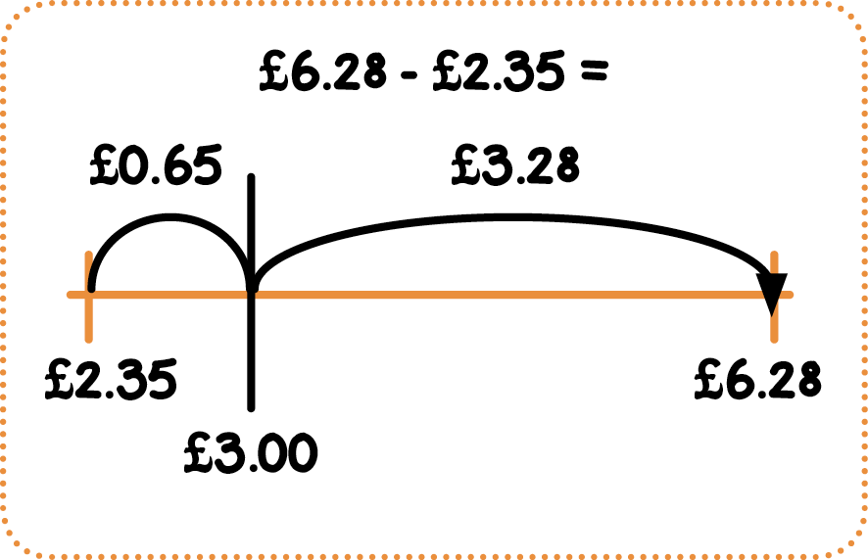

Steps 33 – 34: Using money to solve subtractions
involving U.10th ,100th

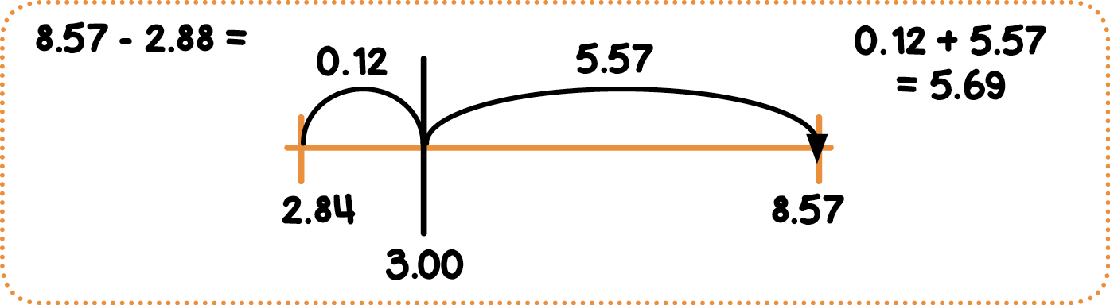

Step 35: Progressing to subtractions U.10th and U.10th 100th

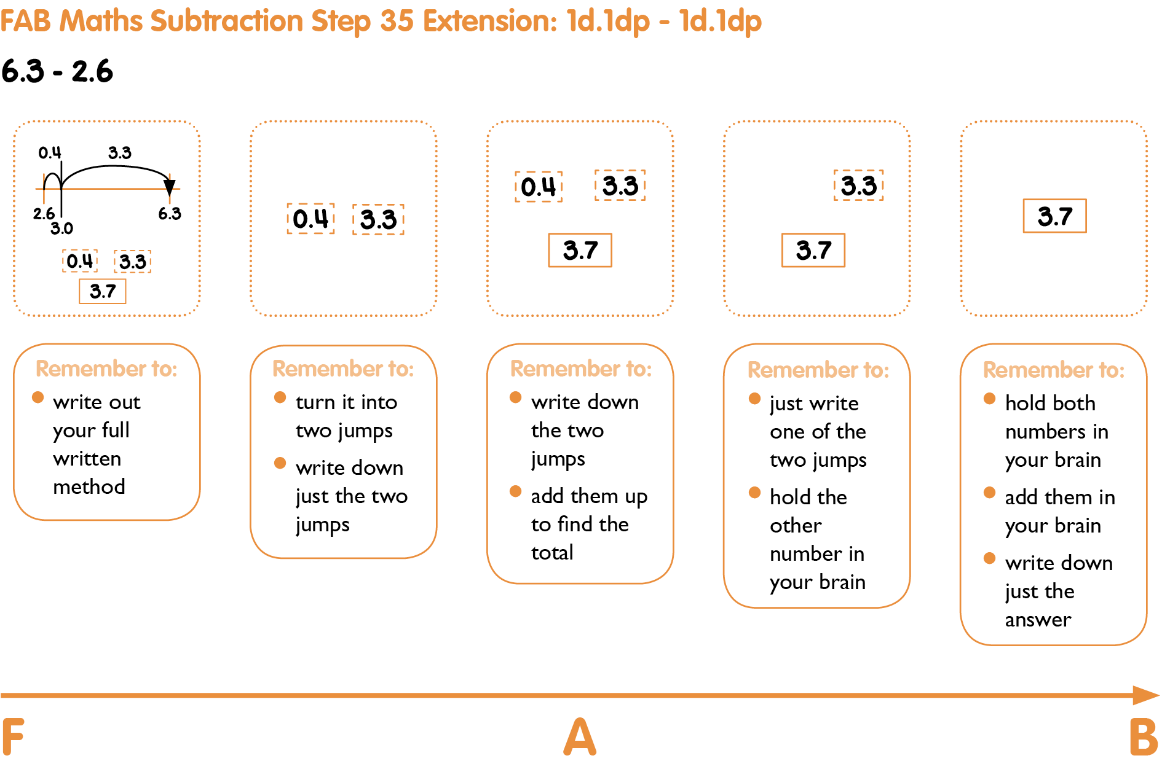

Step 36: Any whole number subtraction e.g. 4888 – 555 / 7869 – 2600 / 12462 - 2300

Step 37: Subtraction of numbers with mixed digits before and after the decimal place.
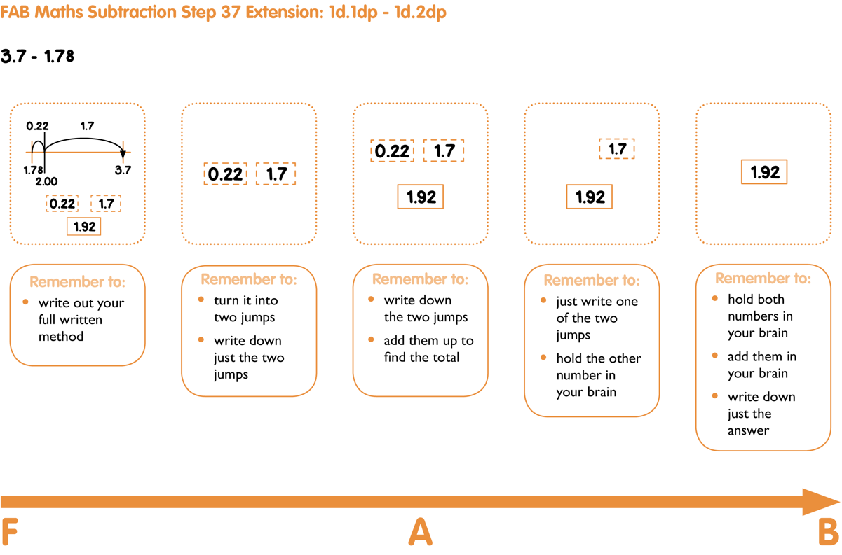

Subtraction: Column Methods

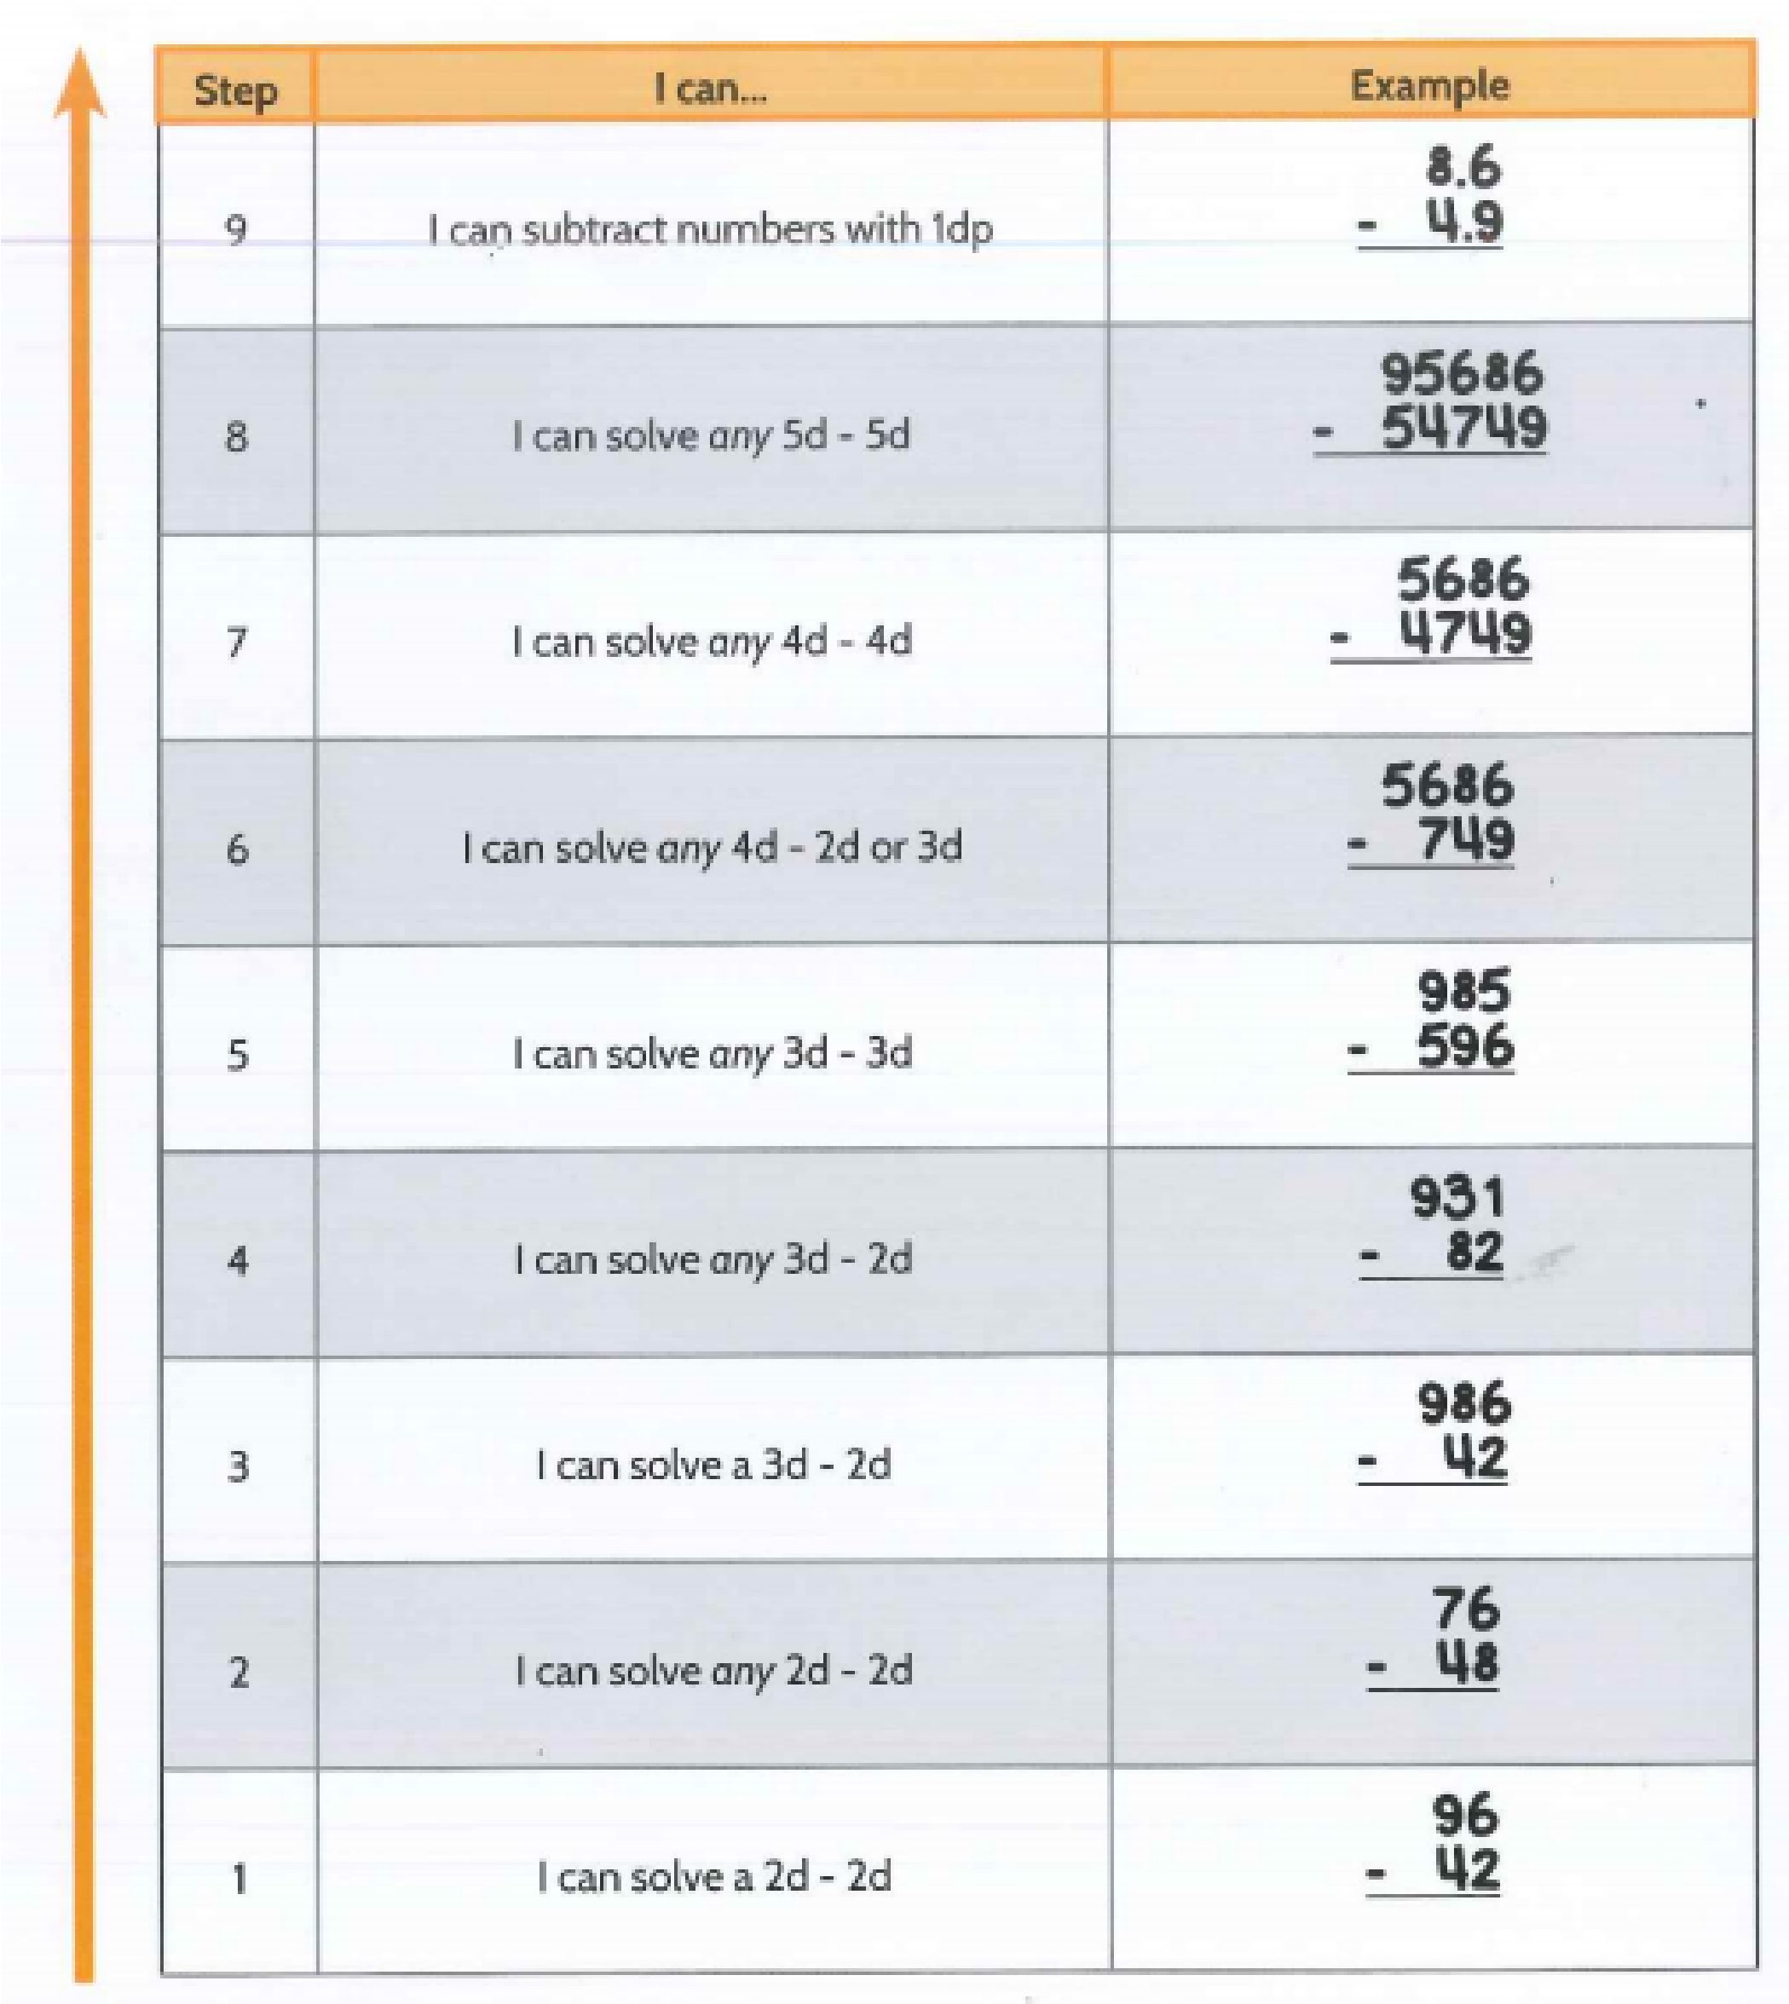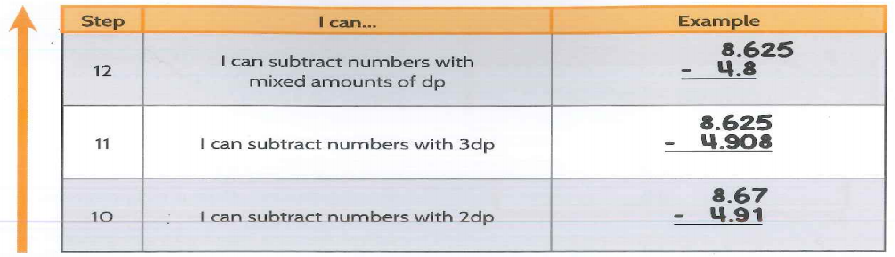

Multiplication Progress Drives

The Multiplication Progress Drive can be split into 3 broad phases of development

Phase 1: Steps 1 – 8
The first phase is the setting and counting of objects in groups (‘lots of’). Setting out the groups comes first and then using the groups to count how many altogether comes afterwards, so there is a 2-step progression there. However, there is also a progress dimension with what the ‘objects’ are. The nature of the objects moves from ‘play things’ (toys) to blocks, to dots, to numbers. This gradually increases the degree of comfort with abstract maths for young children.
Finding total, Setting out | Toys, Blocks, Dots, Numbers
Phase 2: Steps 9 -14
The second phase sees another 2-step progression. This time we move from using ‘Learn Its’ from the 2, 3, 4 and 5 times tables to those from the 6, 7, 8 and 9 times tables. Again, there is a second dimension of progression. Here, we move up from 1d x 1d facts to smile multiplication, to 2d x 1d multiplication.
x 2, 3, 4, 5, 6, 7, 8, 9 | 1d x 1d, Smile Multiplication, 2d x 1d

Phase 3: Steps 15 – 19

The third phase sees the use of smile multiplication skills taking us to competency with tenths and hundredths, and the use of 2d x 1d skills being nudged into 3d x 1d, 2d x 2d and, finally, 3d x 2d.
Tenths, Hundredths | 2d x 1d, 3d x 1d, 3d x 2d

Multiplication: High Understanding Methods
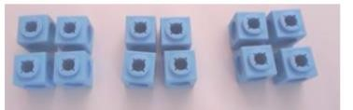

Steps 1-4: The use of physical objects to find totals. For example, three lots of four blocks.

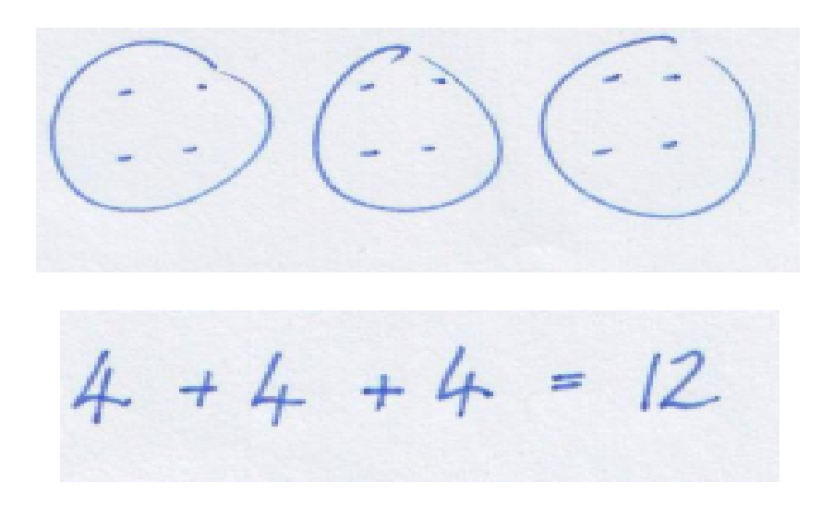

Steps 5-6: Drawing groups of dots and counting the total. For example, three lots of four dots

Steps 7-8: Repeated addition including reading 3 x 4 as ‘3 lots of 4’

Step 9: Using 2,3,4,5 times table ‘learn its’ to multiply 1dx 1d as children should have improving instant recall of these facts by this stage.
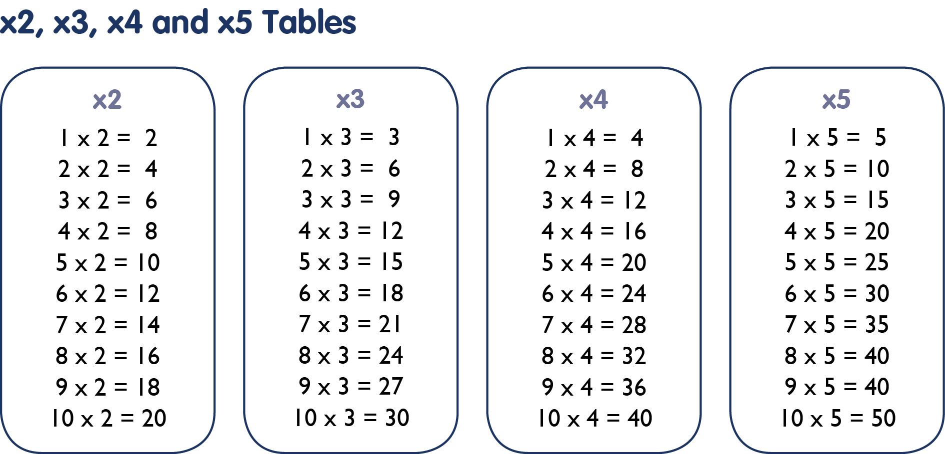

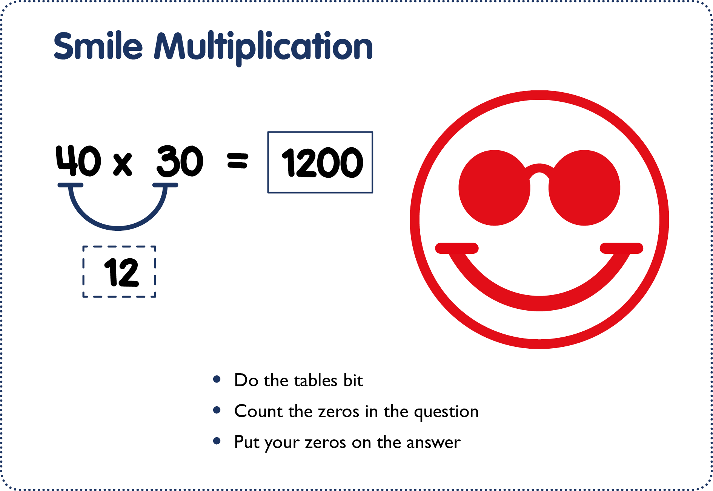
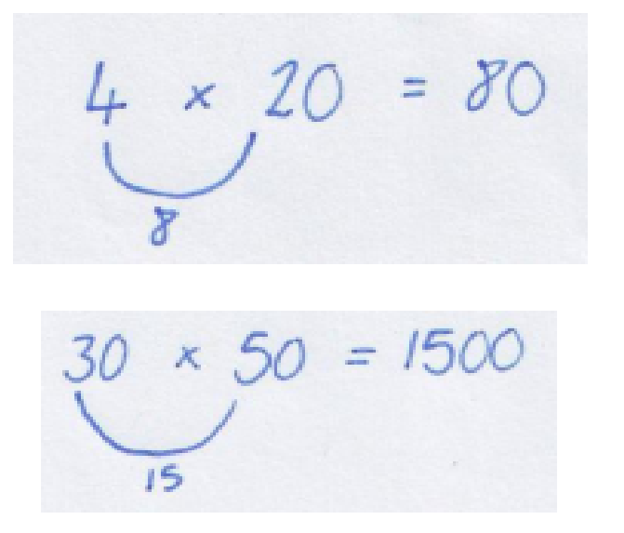
Step 10: Introduction of ‘smile multiplications’ using 1d x 1d ‘learn its’ combined with an understanding of place value

Step 11: Using 6, 7,8, 9 times table ‘learn its’ to multiply any 1d x 1d as children show a development in instant recall of these facts by this stage

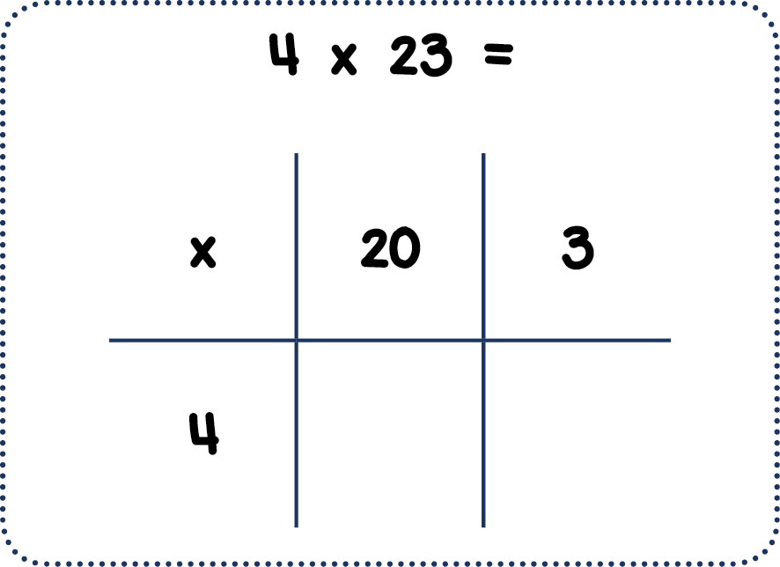

Step 12: Introduction of the ‘grid method’ to solve 2d x 1d (where the 1d is in the 2,3,4,5 times table)
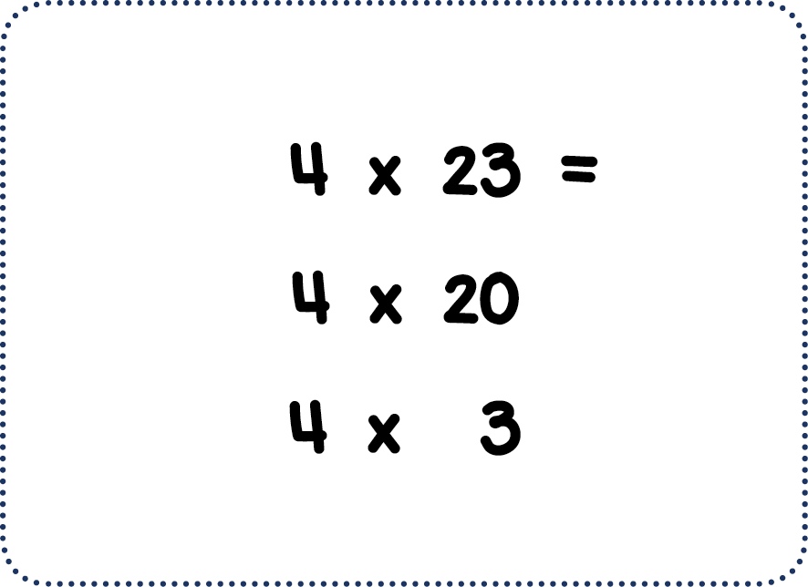

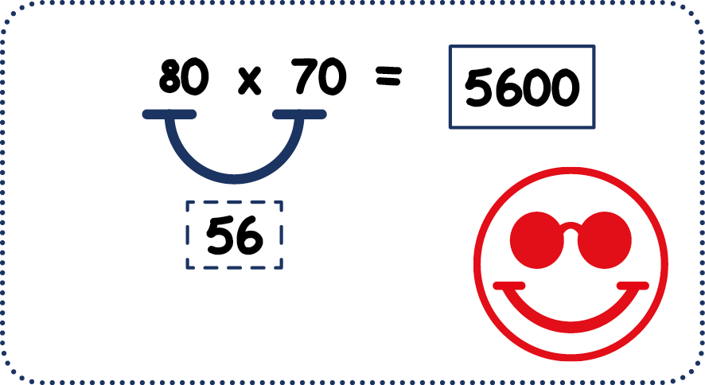
Step 13: Use knowledge of 6,7,8,9 times table ‘learn its’ to solve any smile multiplication

Step 14: Use of the grid method to solve any 2d x 1d

Step 15: Use of the grid method to solve any 1d x 3d

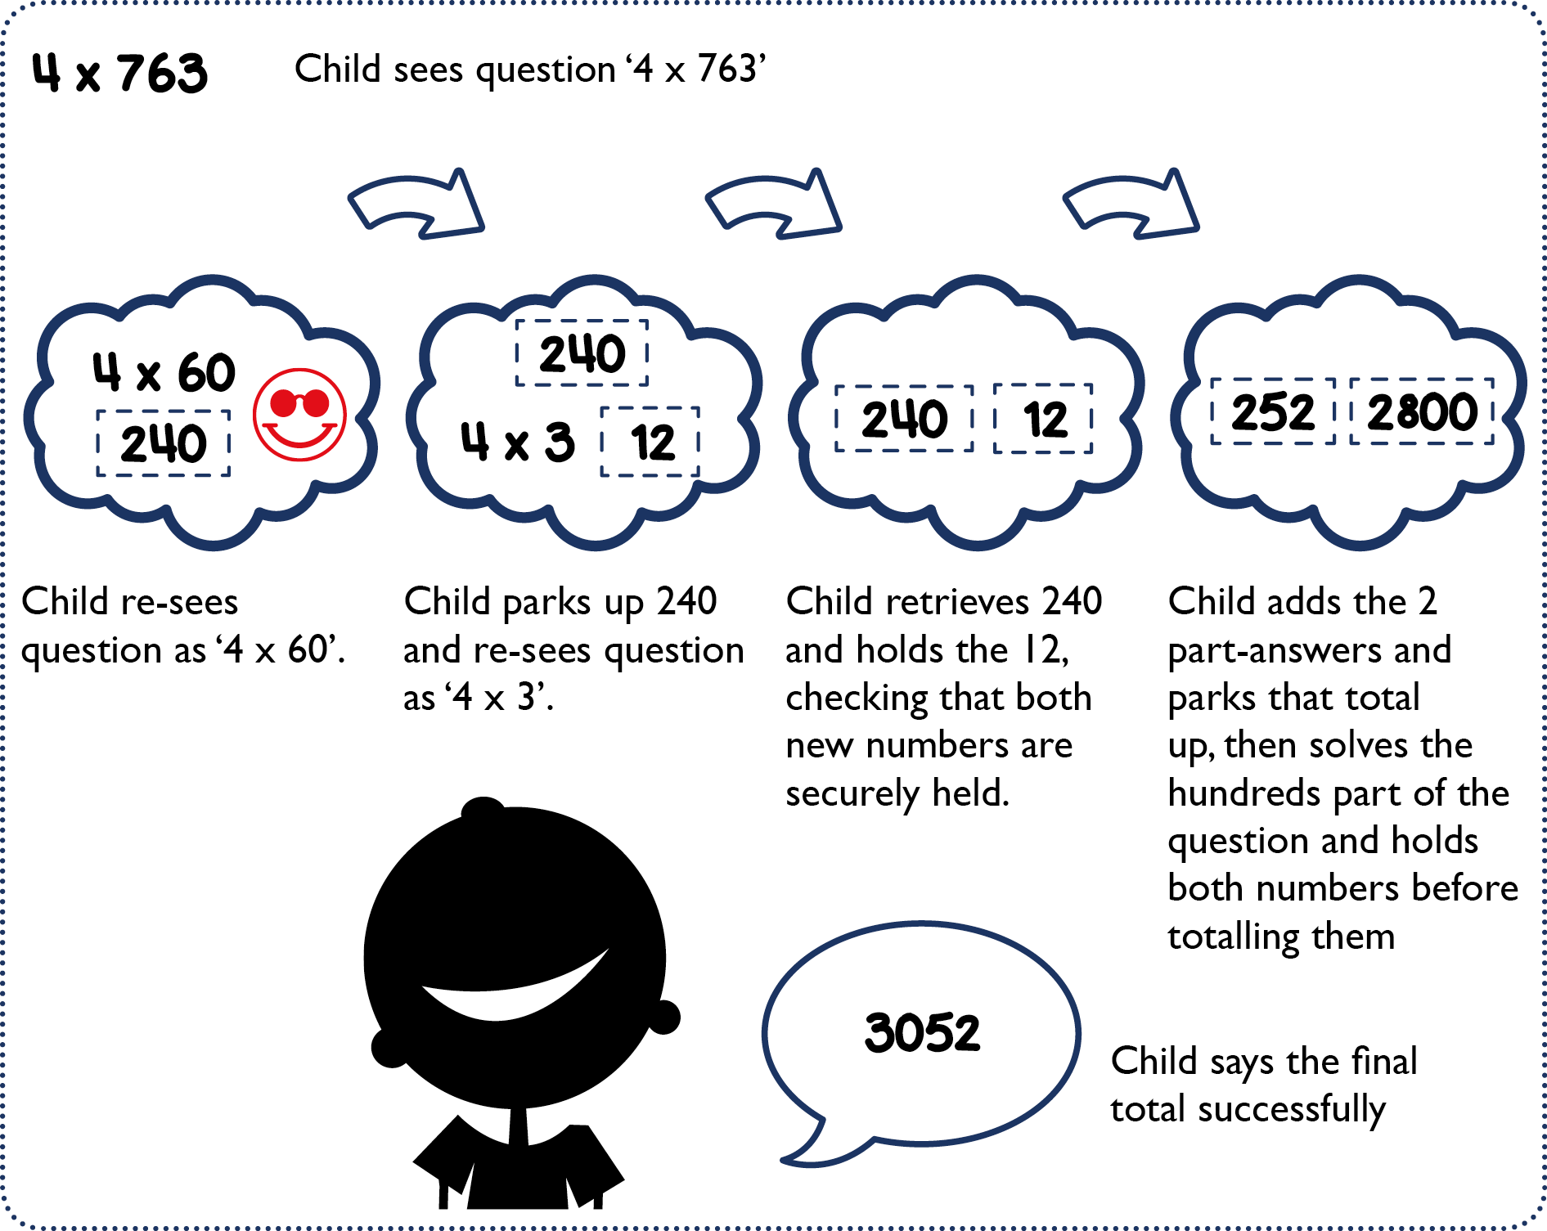

Step 16: Use of the grid method to solve any 2d x 2d
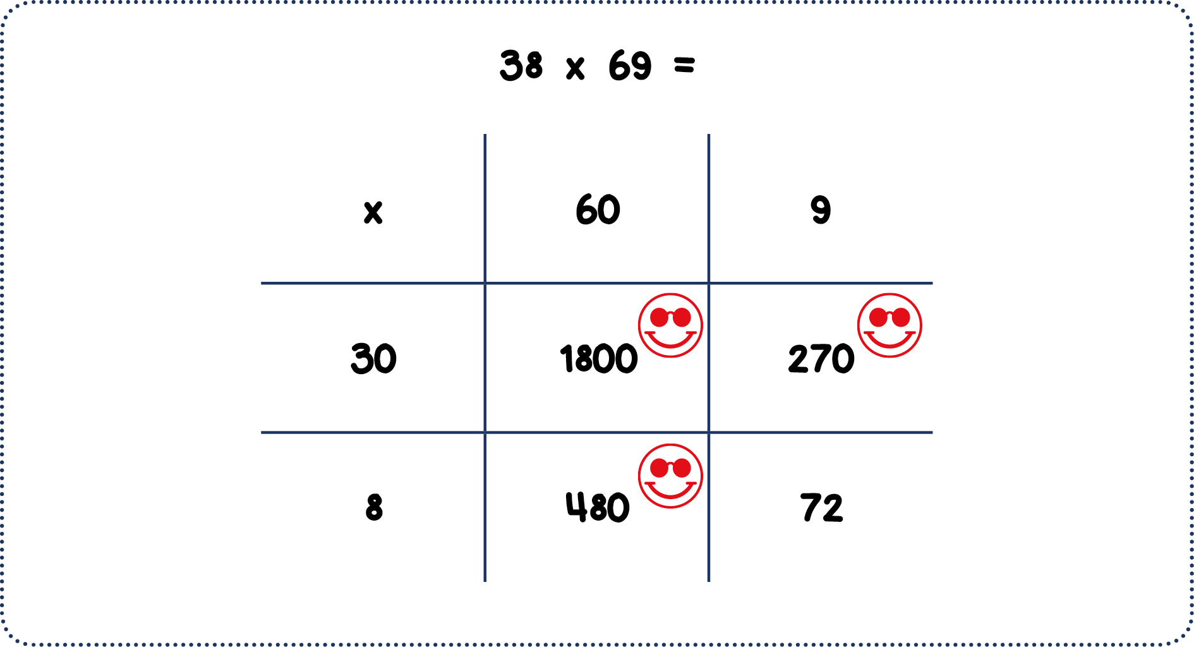

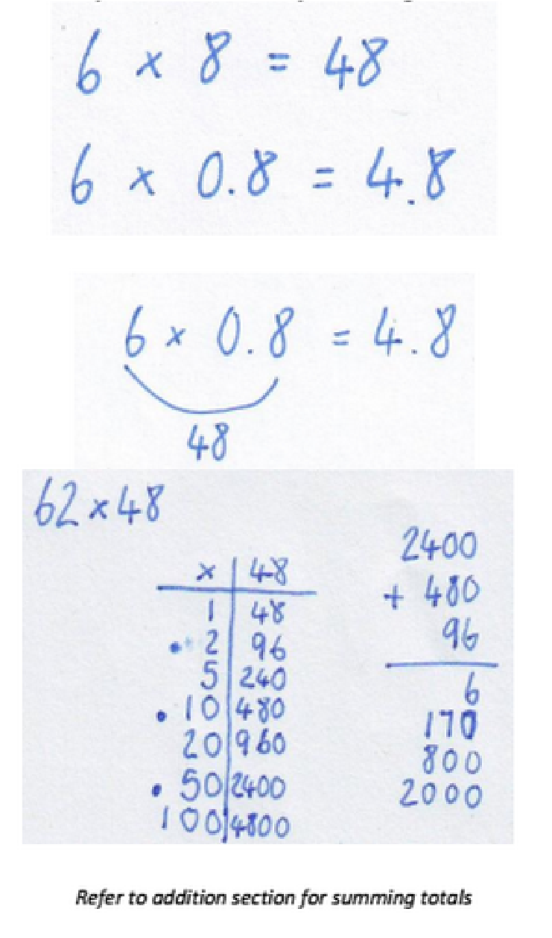

Step 17: Solving 2d x U.10th, using known facts and place value
- Recall times tables fact
- Make the answer 10x smaller

Step 18: Introduction of ‘coin grids’ and the ‘coin method’ to solve 2d x 2d

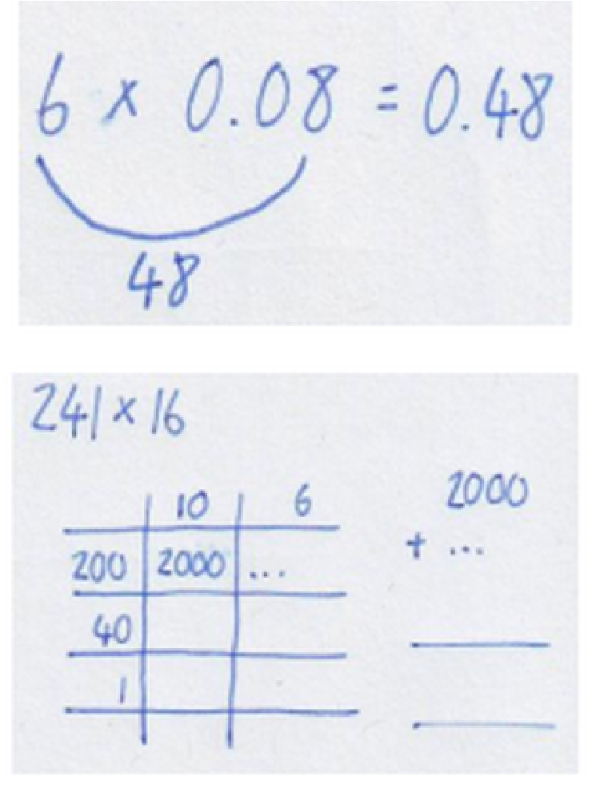
Step 19: Solving 1d x U.10th 100th
- Recall times tables fact
- Make the answer 100 x smaller

Step 20: Use of the grid method to solve any 3d x 2d

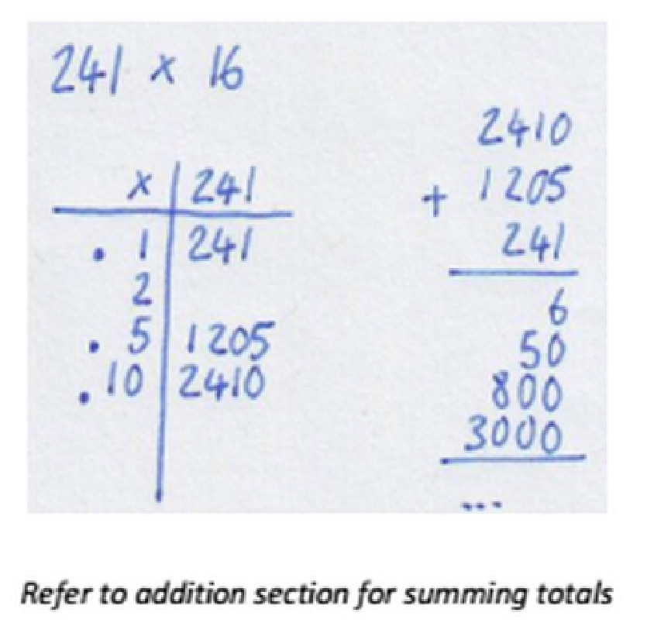

*This step includes the extension of coin grids and the coin method to solve 3d x 2d

*This includes refining the coin grids, so only those values required to solve the problem are found

Multiplication Column Methods
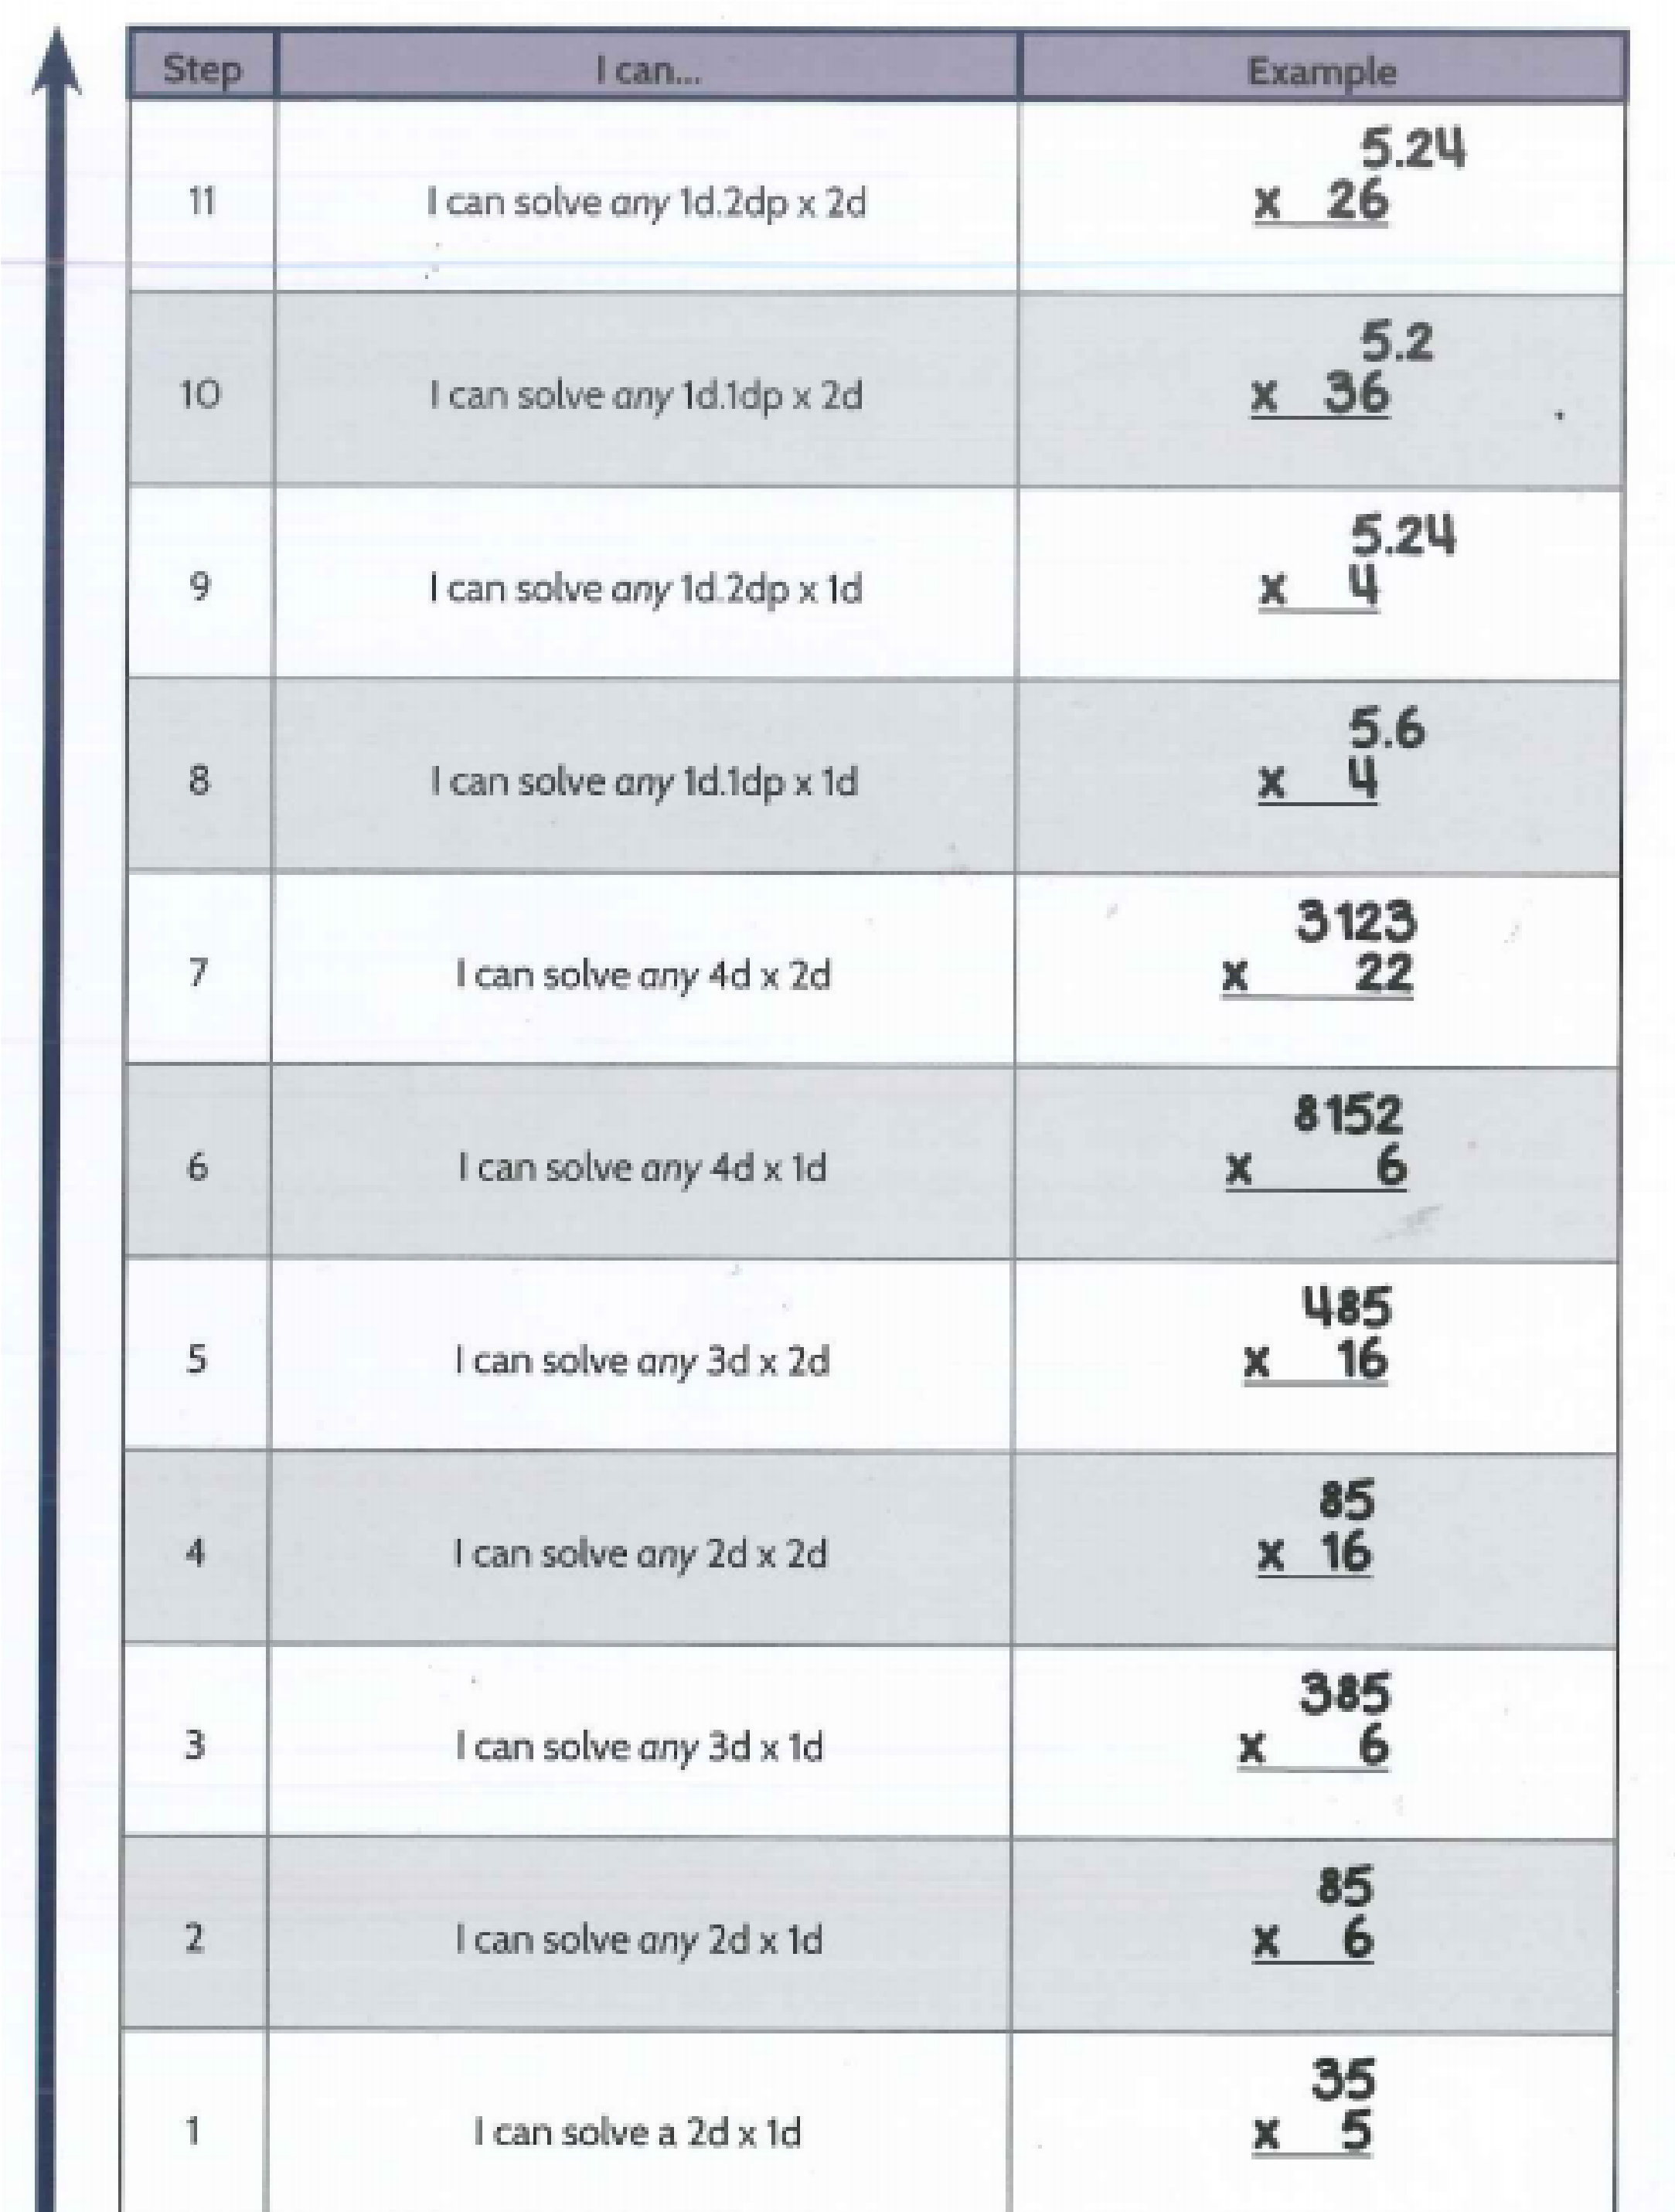
Division Progress Drives:

The Division Progress Drive can be split into 5 broad phases of development

Phase 1: Steps 1 - 9 (Sharing)
The first phase teaches children to divide out amounts by sharing equally into a given number of piles and then seeing how many there are in each pile. This is known as ‘sharing’ and children use blocks or objects that are linked to other areas of their learning to divide out their starting amount.

Phase 2: Steps 10 - 15 (Grouping)
The second phase teaches children to take groups of objects out of a starting pile. The group size is pre-defined and so the question is concerned with how many groups can be taken out from the starting pile before they all run out. This is the practical basis that provides the conceptual foundations for the following three phases.
Phase 3: Steps 16 - 27 (÷1d)
These steps are all about dividing by a 1d number. By using the ‘Where’s Mully?’ division mindset then children look for the highest multiple of the 1d number and then ask themselves which multiple it was. To find high multiples of 1d numbers means the learner must be able to combine use of their tables facts with smile multiplication. Children who are familiar with smile multiplication and ‘Where’s Mully?’ will suddenly find formal division is easy and…fun! This is how we can get all children to divide ‘brain only’. Learners will also start to learn Column Method Division from this point.

Phase 4: Steps 28 - 31 (÷2d)
For these steps, all of the previous thinking holds true in terms of looking for high multiples by using the ‘Where’s Mully?’ division mindset. However, this time, since we are dividing (which is really multiplying when we use this method) by 2d numbers, tables facts are of limited value. Hence, children are shown how to use the coin facts, which they have already learnt how to obtain from earlier CLIC sessions (‘It’s Nothing New’).

Phase 5: Steps 32 - 33 (Decimals)
These final 2 steps challenge the children to solve division with decimals. Again, rather than thinking of ‘division’ as such, smile multiplication provides a clear open doorway into successful understanding and doing.

Division High Understanding Methods:

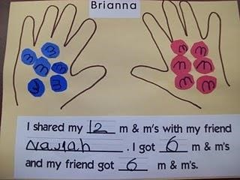
Steps 1-2: Sharing out objects equally / fairly, asking “How many will each person have?”

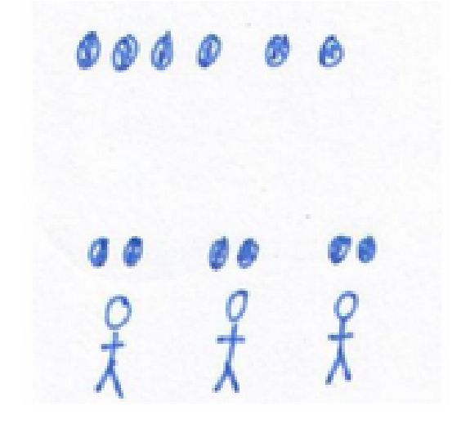

Steps 3-4: Sharing between two, halving even numbers of objects.

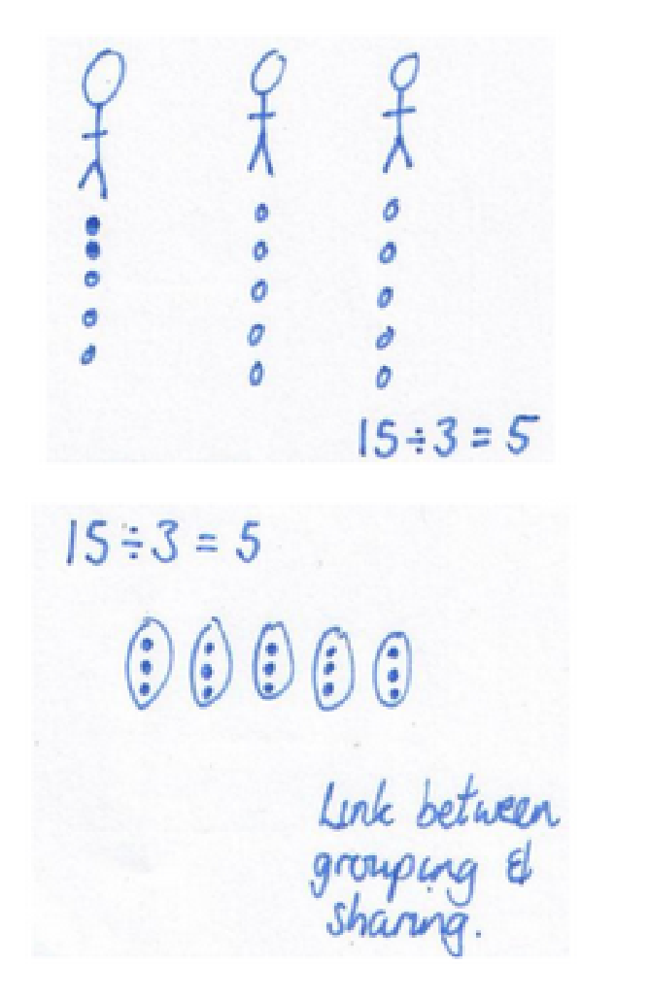

Step 5: Sharing 6,9,12,15 objects between 3.

Step 6: Sharing 6,6,12.15 objects into 3 whilst introducing the ÷ symbol.

Steps 7-8: Sharing 8,12,16,20 between and into 4.


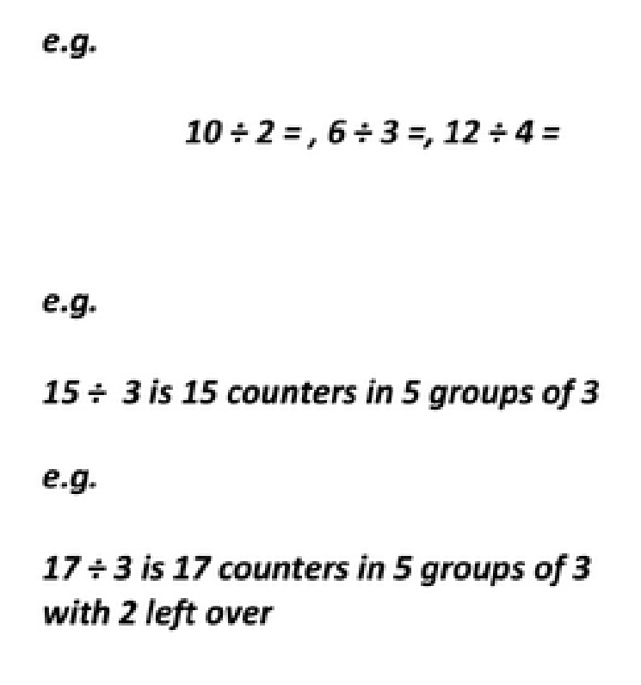

Step 9: Solving ÷2 , ÷3, ÷4 division problems

Steps 10–12: Making groups of 2,5 or 10 and counting.

Steps 13-14: Physically solving a number sentence using objects and counting.

Step 15: Moving onto and exploring remainders.

Step 16: Use of multiplication ‘learn its’ for 2,3,4,5 and 10 times tables to find division facts through ‘fact families’

Step 17: Extending the use of multiplication ‘learn its’ for 2,3,4,5 and 10 times tables to find division facts and remainders.

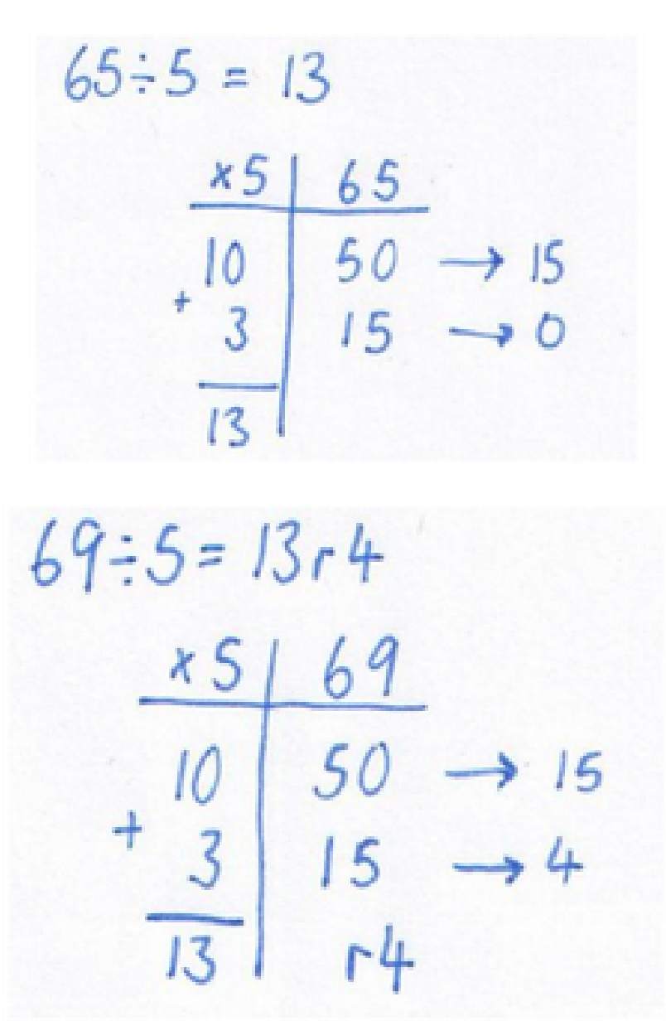

Step 18: Combining two or more 2,3,4,5, 10 x ‘learn its’ to solve division problems using ‘division grids’

Steps 19-21: Extending combining two or more 2,3,4,5,10 x ‘learn its’ to solve division problems involving remainders.

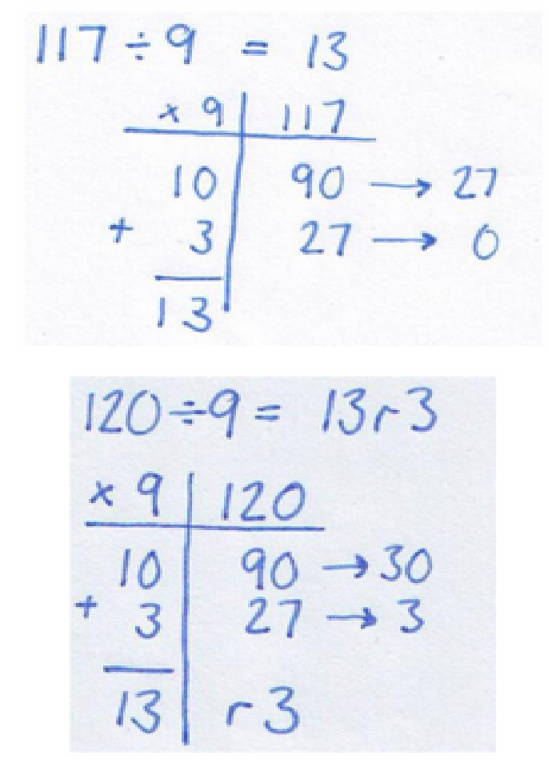
Step 22: Combining two or more 6,7,8,9 x ‘learn its’ to solve division problems using division grids.

Step 23: Extending combining two or more 6,7,8,9 x ‘learn its’ to solve division problems involving remainders.

Step 24: Combining knowledge of smile multiplications and their fact families to solve division problems with greater efficiency.

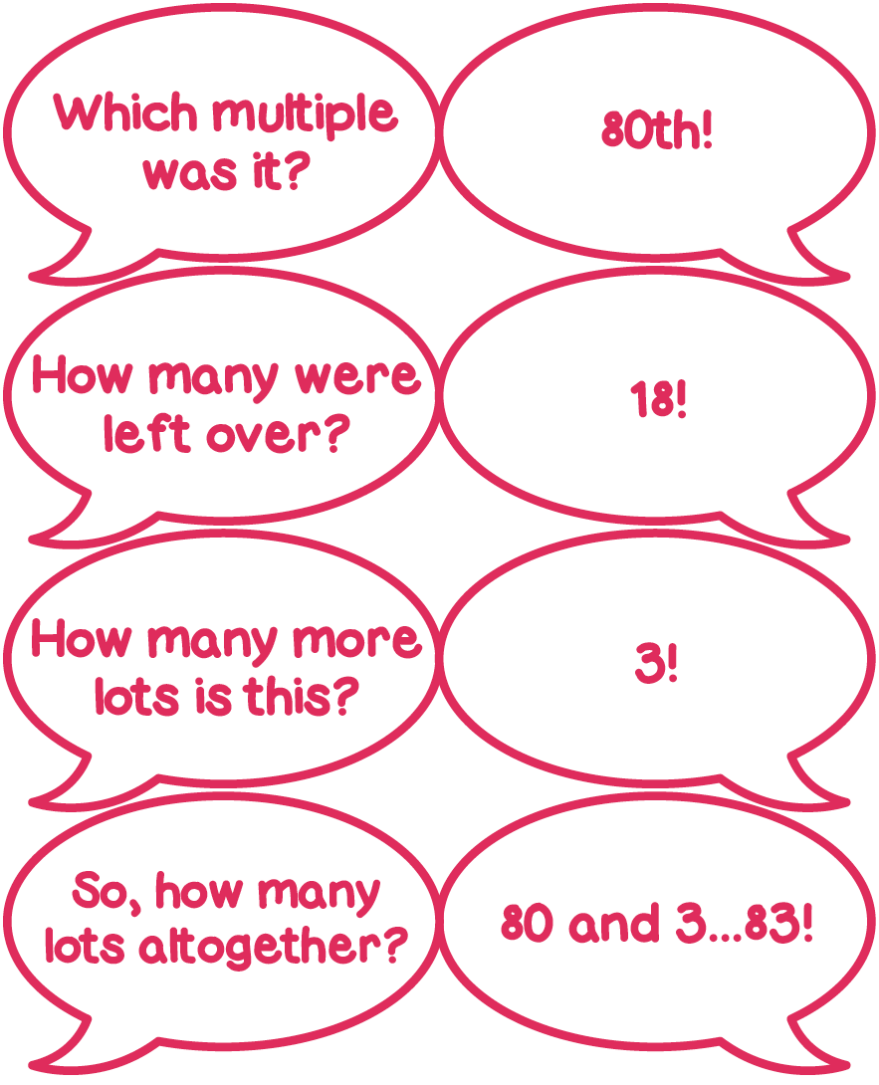
Steps 25-26: Combining knowledge of smile multiplications and their fact families to solve division problems with greater efficiency, including those that give rise to remainders

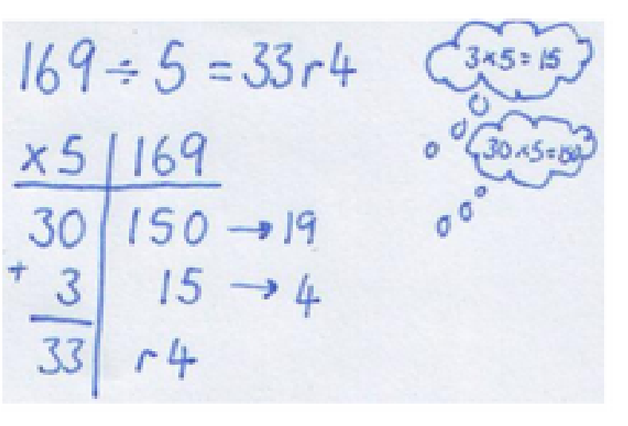

Step 27-28: Extending to solve 3d ÷ 1d, including those that give rise to remainders

Steps 29-31: Extending to those that give rise to remainders:
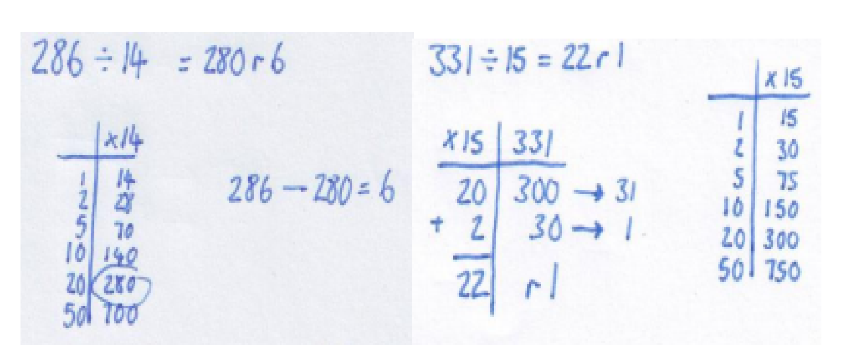

Steps 32-33: Solving decimal division problems using ‘learn its’ and understanding of place value
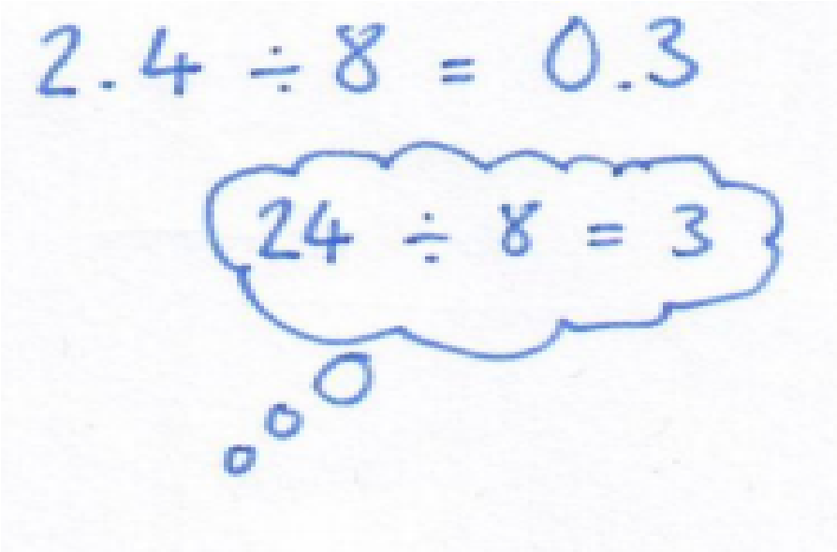

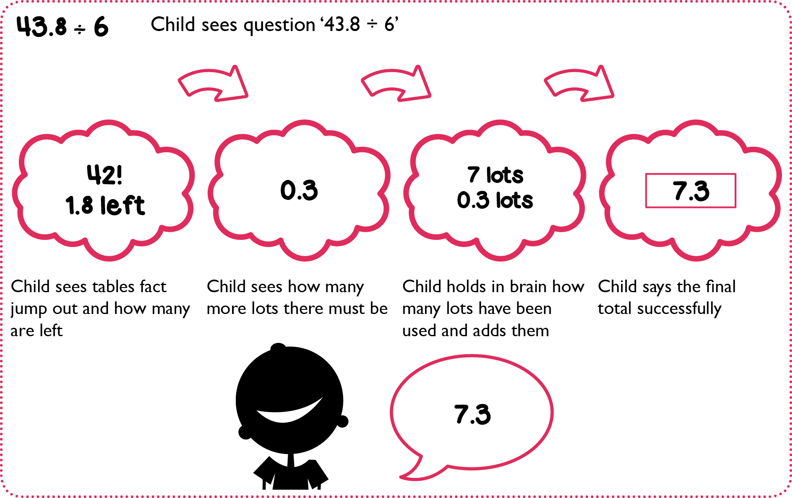

Division Column Methods
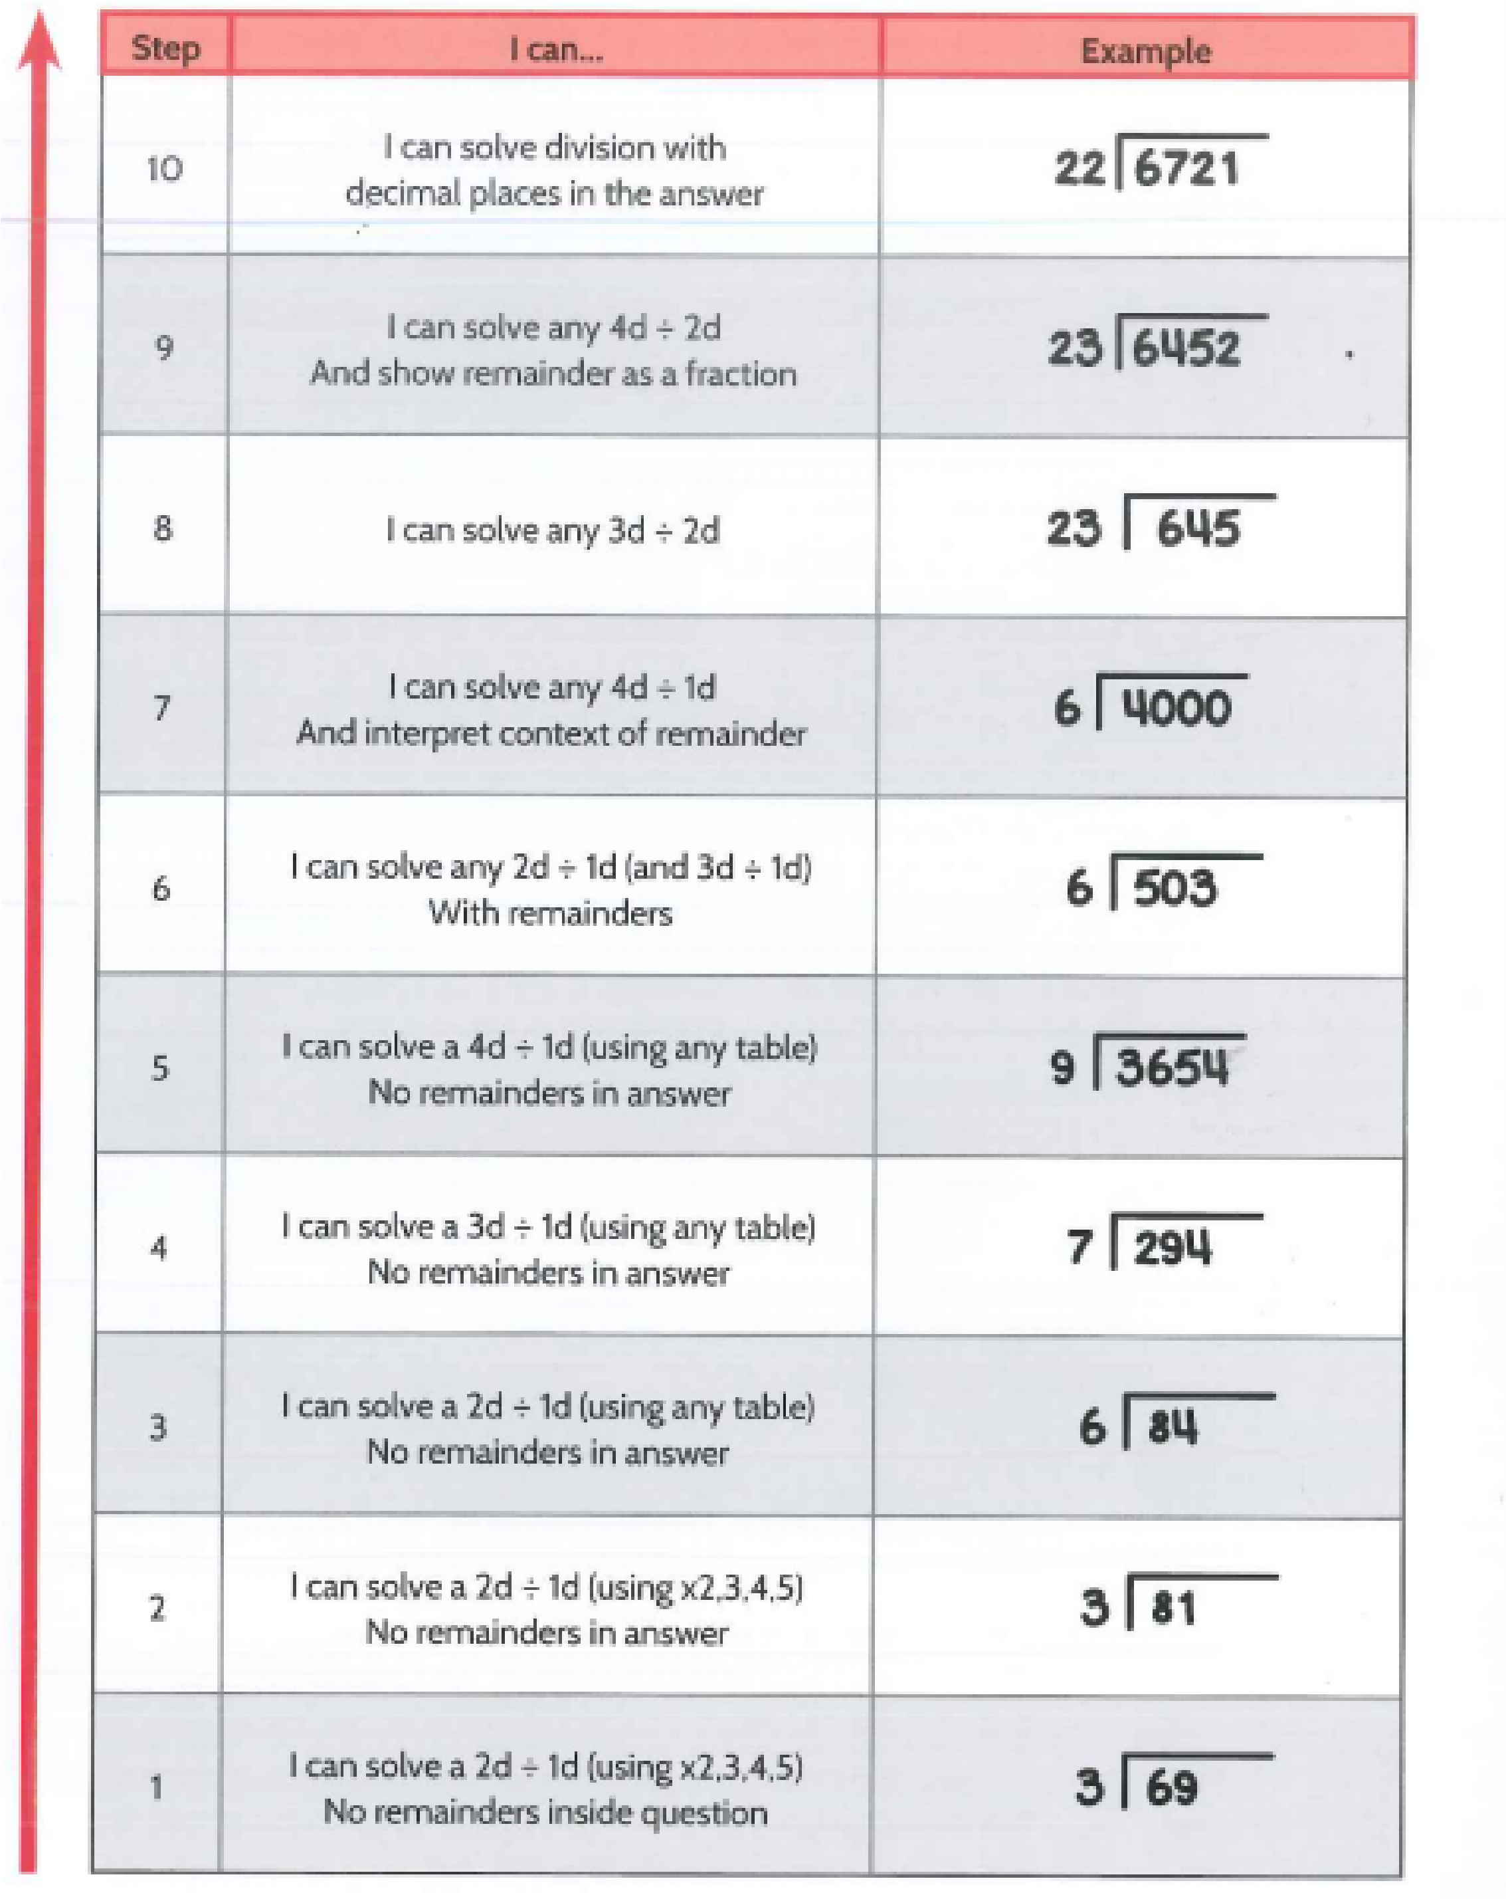
Year Group | Addition steps | Subtraction steps | Multiplication Steps | Division steps
Reception | Steps 1 – 5 | Steps 1 – 5 | Steps 1 - 2 | Steps 1 - 5
Year One | Steps 6 - 12 | Steps 6 - 12 | Steps 3 - 6 | Steps 6 - 11
Year Two | Steps 13 - 24 | Steps 13 - 27 | Steps 7 - 9 | Steps 12 - 17
Year Three | Steps 25 - 28 | Steps 28 - 29 | Steps 10 - 11 | Step 18
Year Four | Steps 29 - 31 | Step 30 | Steps 12 - 14 | Steps 19 - 23
Year Five | Steps 32 - 38 | Steps 31 - 36 | Steps 15 – 16 | Steps 24- 31
Year Six | Steps 39 - 41 | Step 37 | Steps 17 – 20 | Steps 32 - 33
Steps covered in each Year Group

The table above will give you an idea of the expectations in each year group although, it is important to note that in Big Maths children are encouraged to consolidate and build on their previous knowledge so some steps may be covered in more than one Year group.

